Truncation and Wildcard Symbols
* | The asterisk is a wildcard that matches zero or more characters. For example, a search on 'Sam*' will bring back results that include 'Sam', 'Samantha', 'Samuel', etc. You can also search alternate spellings with the asterisk (*), which represents 0 to 5 unknown characters. The query Johann* will search for Johann and Johannes. A query for Smel*er will search for Smeltzer and Smelzer, among others. Note: You cannot use an asterisk as the first, second, or third character of a search term.
? | The question mark acts as a single-character wildcard. For example, a search on 'Eli?abeth' will bring back results that include 'Elisabeth' or 'Elizabeth'. Note: You cannot use a question mark as the first character of a search term.  NOTE: Using these symbols in combination is also an acceptable pratice. For example, a search for Eli?a* will return hits for Eliza, Elisa, Elizabet, Elisabet, Elizabeth, and Elisabeth, as well as Elijah, Elimar, etc.

Keyword Searching
The Keyword field can be used to search for any word you would expect to be found in the database you are searching. This can include things such as an occupation or a location. You are able to only search for keywords. Keep in mind that if you enter more than one term you will need to use quotation marks to ensure an exact phrase search, such as “The Great War.” If you choose to combine a name with a keyword and the database finds a match for the name, but not the keyword, it will not provide the results for you.
The Keyword field can be found on the following pages:
- Card Catalog
- Advanced Search
- Content category search pages
- Specific collections search pages

Home Tab (i.e., Basic Search)
The Home tab (or Basic Search) searches across all source types in all collections by entering First, Middle, and/or Last Name details in conjunction with other optional fields:
Name a place where your ancestor might have lived – Auto-complete (e.g., type-ahead) options for locations will appear as you type. Continue typing or select from the options presented.

Birth year (with birth year calculator)

Show More Options - Click the "Show more options" link to add more precision to your search by including other known details (see box below for the expanded view of the search form).
  - Add Events: Birth, Marriage, Death, Lived In, Any Event, More: Arrival, Departure, Military
  - Add Family Members: Father, Mother, Sibling, Spouse, Child
  - Keyword
  - Gender
  - Race/Nationality

Use the links found in the Quick Links, US Census, UK Census, or Canada Census Records boxes to narrow your search to more specific collections. Click the Card Catalog link to see all available data collections and select a category, sub-category, or one specific collection for searching or browsing.
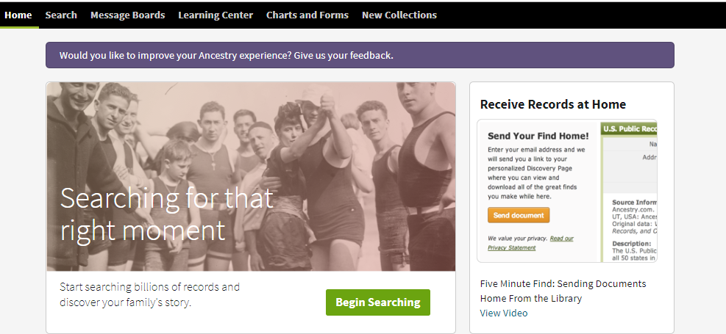

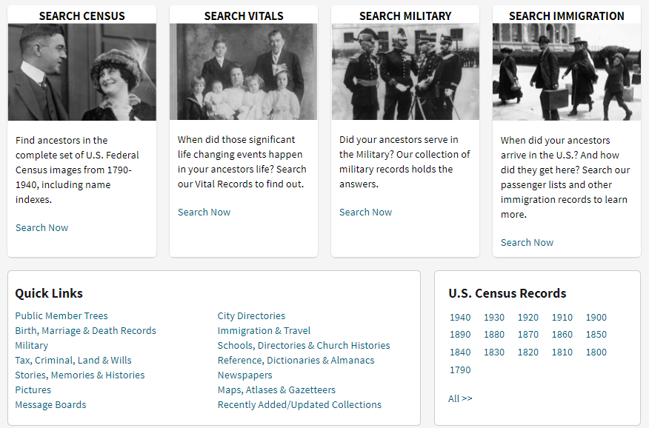

Show More Options" Expanded View
Choose the Show More Options link from the Home tab or Search tab to display more parameters to construct a refined search as noted in the box above.
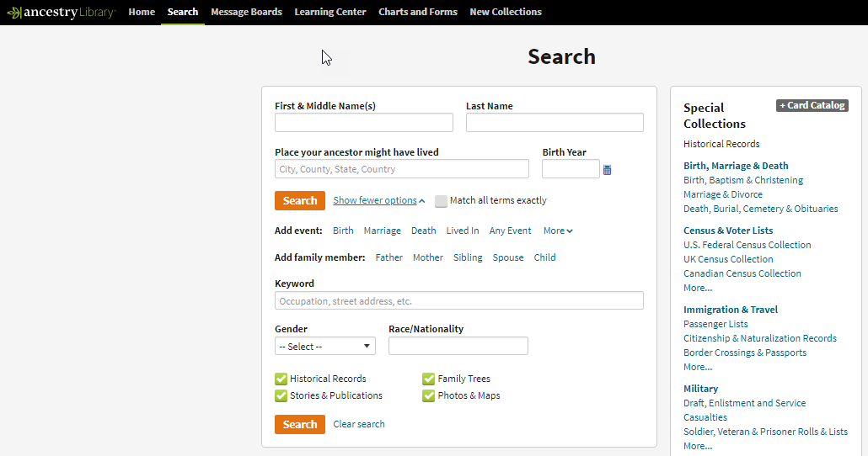

Exact Match Limits
Exact Match options appear when you begin typing data into a search field. Exact matching options vary by field:
First & Middle Name
- Unchecked Exact box = broad search for all forms of the name entered*
- Checked Exact match box = Exact match of what is entered into the search field
Locate spelling and sound variations of the name you entered by selecting from the additional options:
- Sounds Like = Phonetic matches
- Similar = Names with similar meanings or spellings
- Initials = Records where only initials are recorded

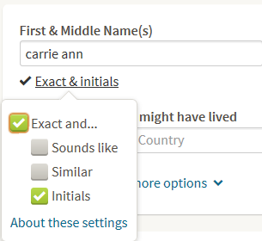
Last Name
Restrict to exact matches and:
- Phonetic matches
- Names with similar meanings or spellings
- Initials = Matches the name you typed
  - Unchecked Exact box*
  - Checked Exact box = Exact match of what is entered into the search field.
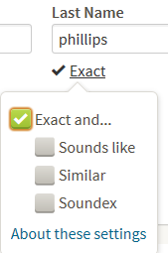
*Unchecked Exact box: When you use default settings, the system looks through every first name we have recorded in the data collections, and retrieves any record where the first name is:
- Exactly what you typed
- A phonetic match of what you typed
- A first name which has a similar meaning or spelling as the one you typed
- An initial that matches the name you typed
- We may also return records that do not match the first name you typed in as described in this list, but strongly match other criteria
These records are also evaluated against the other criteria entered, and are ordered based on how well all the elements in that record match your search.
Soundex is a common algorithm used to generate alternate spellings of a surname. If you choose this option, any record that contains one of the Soundex variations for a surname might appear in your results.

Search Tab
Click the Search tab to access the basic or advanced search page, additional search tools such as the listing of major categories and subcategories, as well as the Explore by Location interactive maps. The search form on this page is exactly the same as is seen on the Home tab; click the "Show more options" link to access additional search fields.
