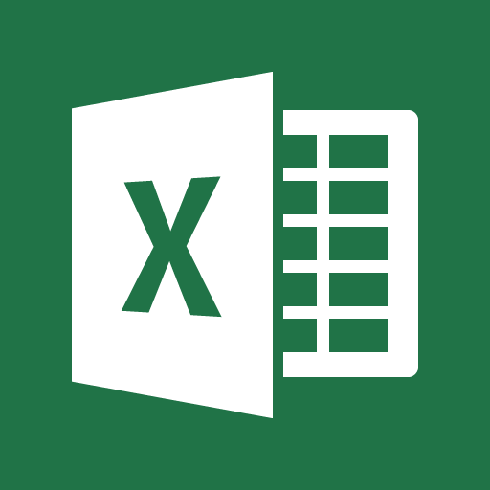
Microsoft Excel 2016
Document Outline
- What is Microsoft Excel?
- Open Excel and Create a Spreadsheet
- Important Terms
- Components of the Interface
- Navigation
- Data Entry
- Formatting
- Basic Equations
- Saving and Printing
What is Microsoft Excel?
Excel is a spreadsheet program used for storing, organizing, and manipulating data. It uses grids of text, numbers, and formulas, and has the ability to generate graphs and charts. It is part of the Microsoft Office Suite, which also includes Word and PowerPoint.
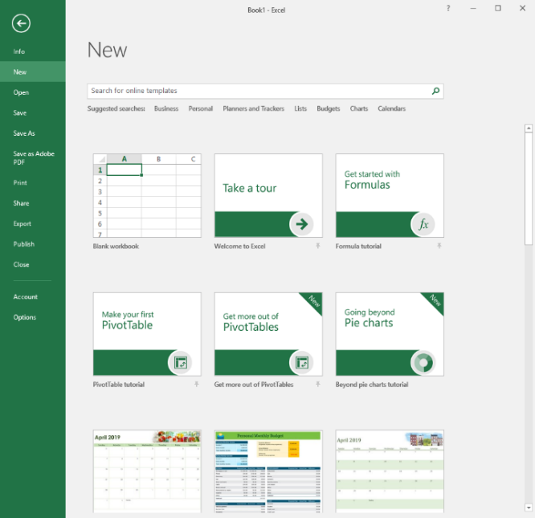
Open Excel and Create a Spreadsheet
To open Microsoft Excel, click on the icon, which looks like the image above (green X over a grid). This might be found in the taskbar at the bottom of the screen, as a shortcut on the desktop, or in the “Start” menu (bottom left of the screen). Applications in the “Start” menu are arranged alphabetically.
Upon opening the application, you will be asked to open a new document. You can choose “Blank Document” (the most common choice), or work from a provided template. Templates are useful for calendars, budgets, invoices, and more. Finally, there is the option to choose a tutorial. These are learning modules provided by Microsoft, which show basics and provide examples.
Important Terms
- Worksheet – A single page in Excel. Various worksheets are found in tabs at the bottom of the screen.
- Workbook – The entire Excel file, or document.
- Cell – One rectangular block in a worksheet. All data in a worksheet must be in a cell. Each cell is a unique location.
- Columns and Rows – Refers to how your cells are aligned. Columns are aligned vertically while rows are aligned horizontally.
- Column and Row headings — Headings are the lettered and numbered gray areas found just outside of columns and rows. Clicking on a heading will select the entire row or column. You can also alter the row height or column width using the headings.
- Cell Address – The column letter and row number of a cell. (For example, A1 or B6.)
Components of the Interface
- Title Bar – The uppermost row of Excel, which contains the title of the current workbook. The default title is “Book1”. In the top right corner, Minimize, Maximize / Restore Down, and Close can also be found.
- Ribbon – Above the workbook is a section of command tabs called the Ribbon. A multitude of options are found behind each tab of the ribbon. The available tabs are:
  - Home – Where the most frequently accessed features live, such as formatting
  - Insert – Adds content beyond text to the page (e.g. graphs and pivot tables)
  - Page Layout – Changes how the page prints (e.g. margins)
  - Formulas – The core of Excel’s usefulness! The tools in this menu help Excel do math for you.
  - Data – Organizes and summarizes the data in your workbook
  - Review – Spell check, Thesaurus, and the tool to add comments are found here
  - View – Changes how the page appears digitally (e.g. gridlines and zooming).
- Page View – Found at the very bottom of the Excel Window. Page View allows you to switch between worksheets, as well as different ways to display the sheet.
- Formula Bar – Displays the contents of a cell, including any mathematical formulas that have been created.
Navigation
- Click in a cell
  - When you open a workbook, you will automatically start with cell A1 selected.
  - You can tell which cell is selected because it is surrounded by a thick black box.
  - You can move to any cell in your workbook by clicking on it.
  - The arrow keys can also be used to navigate between cells.
  - The column letter and row number will be highlighted when you select a cell.
- Enter: move one row down.
- Tab: move one column to the right.
- Multiple cells can be selected at the same time. Standard commands such as “Ctrl + Click” and “Shift + Click” can be used, as well as clicking the Column or Row Heading.

Data Entry
When a cell is selected, you can type to add text and numerical information to that cell.
To practice, we are going to create an example budget. We will start to try out some formatting options and basic math formulas, listed below.
Formatting
- Cell Size – If the text or numbers in a cell go past the allowed column width, it will appear to get cut off if there is a value in the cell to the right. You can adjust the column width to accommodate all of the text. To do this, Put your cursor on the line separating columns A and B in the column headings. Click and drag to the right to make the column wider. Additionally, you can double click on the line separating columns A and B, which changes the column size to fit the longest row of text.
- Font, Formatting Text and Cell Color – Font can be changed to be many different type faces, found in the top of the screen under the “Home” tab. Size can also be altered. Text and numbers can be turned a different color, and the cell can be filled in with color. Text can also be bolded, underlined, and italicized.
- Alignment – Data can be aligned to be at the top, center, or bottom of a cell. The justification can also be changed to start at the left, center, or right of a cell.
- Merge and Wrap Text – Multiple cells can be merged into one with the Merge tool. If there is a lengthy bit of text, it can be wrapped to fit in a cell.
Auto Fill and Basic Math Equations
Auto Fill - Excel has been programmed to understand cycles, like after January comes February, and Tuesday comes after Monday. This means we don’t need to type in all that information. Type the first item in the cycle. Confirm the value by pressing Enter. Click and drag the Auto Fill handle (the green square in the lower right corner of the selected cell). Once you get to where you want to stop, release the mouse. This also works for math formulas.
Basic Math Equations – Excel has the power to do work for you. In the Formula Bar, you can enter a basic math problem such as “=1+2”. Upon pressing Enter, the cell will now read “3”. The Formula Bar also understands subtraction, multiplication, and division, among many other things. You can also perform math functions on cells themselves. Try entering “=E4+E5”. This will add together the two values in those cells.
Number Formatting – Numbers can refer to many different things – quantity, currency, percentages, and more. Numbers can be formatted to reflect this.
Auto Sum – Instead of entering each cell to add together, Select all the cells you wish to add and click the Auto Sum button. Press Enter to confirm the value.
Saving and Printing
Printing – Many worksheets are going to be too big to fit on one sheet of paper. If you need to print out a worksheet, you need to decide what you want to print and in what order. Go to the File tab and select Print. This gives you a Print Preview and a few printing options. Use the dropdown menus to the right to manage the print job:
- Change orientation to landscape.
- Change the margins to narrow.
- Use scaling to make the budget fit on one page.
Saving – The first time that you save a workbook, you will also be given the option of naming that workbook. The Save function is located in the File tab of the Ribbon menu. Click on the File tab and then navigate to where it says Save. A pop-up box will then appear. Type the name in the File name box. You can also choose the file type. Excel Workbook is the most common.
Save your progress often while working in excel by clicking Save. This will overwrite existing progress. To create a new version, choose Save As.
Additional Learning Resources
Lynda.com is an online learning platform that provides free, professional learning videos for BAL cardholders. Login with your library card and search for “Microsoft Excel” for relevant video tutorials. The login page is linked here: http://bit.ly/2FMk4zJ
If you would like further assistance from our staff, you can make a 1:1 appointment through our website with this link: http://bit.ly/2IuHr2k

