Podcasting
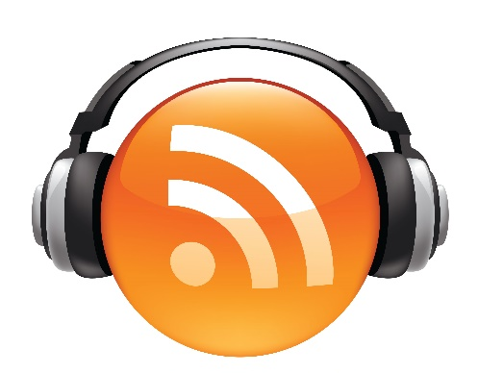
Document Outline:
- Introduction
- Topic, Audience and Format
- Equipment and Software
- Recording and Editing
- Publishing
- Library Resources

What is a Podcast?
Podcasts are digital audio files made available on the internet for downloading to a computer or mobile device. They can be serialized, episodic, or standalone content. Some podcasts are fiction dramas, while others are news programs that also air on the radio. Many are informational, commentary, or rely on themed interviews with interesting guests.
Topic, Audience and Format
Are you interested in producing your own podcast? The first thing you must do is plan. Answering the following questions can provide clarity and direction for your endeavor:
- Why do you want to make a podcast? Perhaps this a business or marketing project, or maybe you are looking to pursue it as a hobby. Be sure to determine the subject and focus of the content before recording.
- Who is your audience? Consider what types of people might listen to your podcast. Maybe your focus is relevant to a certain community, either geographically or centered on a certain topic.
- What form will your podcast take? Come up with some initial episode ideas. Decide on how long your episodes will be, and how often they will be released. The format will be dictated by your content and audience.

Equipment and Software
To make a podcast, you really just need two things: a microphone and a computer with recording software (DAW). However, there are additional items you may wish to invest in to enhance the quality and effectiveness of your production.
- Computer (with DAW): A computer with a Digital Audio Workstation (DAW) will allow you to record and upload .mp3 audio files. Common DAWs for podcasting include Audacity, GarageBand, Logic Pro, and Adobe Audition.
- Microphone(s): The easiest way to record is with a USB microphone. Do not use your computer’s built in microphone. If you are recording with multiple people, you will need a microphone with an XLR Output, along with an audio interface and related cords.
- Audio Interface: An audio interface is the bridge between your microphone and computer. The XLR microphone plugs into the interface, which then connects to your computer via USB port. This allows the analog signal to become digital.
- Mixer: A mixer gives you more control over levels of multiple inputs. It’s especially necessary if you plan to have call-in guests recorded via phone or Skype.
- Pop Filter / Wind Screen: Pop filters eliminate harsh “p” and “b” sounds when speaking.
- Monitoring Headphones: Wearing headphones while recording allows you to hear yourself while speaking, and prevents built in output playback from getting recorded. Highly recommended! This will save you from making mistakes and doing lots of retakes. Earbuds aren’t quite good enough. Over-Ear headphones are recommended.
- Headphone Amplifier: If you have several hosts, a headphone amp will allow each person to have a pair of headphones. It is also a headphone splitter.
- Microphone Stand: USB microphones tend to have a built-in stand, but if you’re using XLR microphones, you’ll need a dedicated stand.
- Shock Mount: This will minimize unwanted sounds like taps on a desk, and table movements.

Recording, Editing, Mixing:
It is worth spending time to learn to use your chosen audio production software. Barrington Area Library cardholders have access to Lynda.com, a fantastic resource with video tutorials from working professionals about every aspect of the process.
Here are some basics: All DAWs have the capacity to record audio, as well as edit and mix. What are some reasons to edit?

Editing:
- Add a music / theme song to your podcast
- Remove unwanted noise or gaps from a recording
- Create a natural segue between two disparate recordings
- Cut out low-quality or boring pieces from a conversation. This can include deleting whole parts, or compiling together multiple takes into something interesting
- Add narration
- Insert other content, such as an advertisement
- Use one section of a recording twice within the project
- Change the structure of an interview, for instance to change the order in which a topic was discussed.
Mixing:
The main purpose of mixing is to balance the track. This means adjusting the volume of each piece, especially in relation to each other. Is one voice louder than the rest? Does the volume get really loud when the theme song plays? Balancing also includes panning (left and right speaker balance). Another aspect of balancing is fading in and out, at the beginning and end of the project, as well as within segments.
Podcast Hosting:
When you have finished recording, editing, and mixing, you will need to upload the final MP3 to a podcast host so others can access it in their podcast feed. Other things that get uploaded include the show description and artwork. You then submit the RSS feed to a directory (iTunes, Stitcher, Spotify, Pocketcasts), which is how the subscriber gets the content.
Learning Resources:
Lynda.com (a library provided database, must have BAL card to use at home, available to all for in library use.)
Here is a useful article on podcasting:
https://www.thepodcasthost.com/planning/how-to-start-a-podcast/

