Snowy Owl

Overview
This project is for adults and children in second grade and up.
Materials
- Pine cone
- Cotton balls
- Cotton swabs
- Googly eyes
- Yellow, black and white felt
- Sharpie
- Glue

Instructions
- Pull cotton balls into small pieces.
- Stuff small pieces of cotton balls into the gaps in the pinecone until the pinecone is filled.
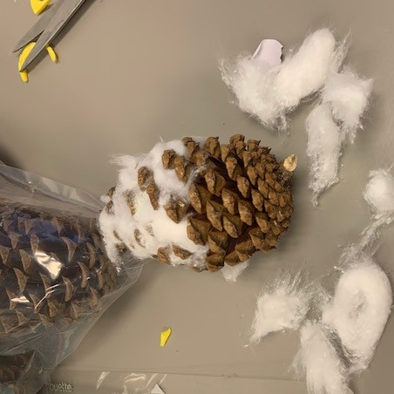
- Peel the backing off the googly eyes. Stick to yellow felt circles.
- Using tacky glue, glue the eyes to the pinecone.
- Peel the backing from the black felt beak. Stick to pinecone. Use additional tacky glue if necessary.

- Draw wing marks on the white felt with the sharpie.
- Peel backing off of white wings. Stick to sides of pinecone. Use additional tacky glue if necessary.
- Great job making your Pine Cone Snowy Owl!
