Woodland Card

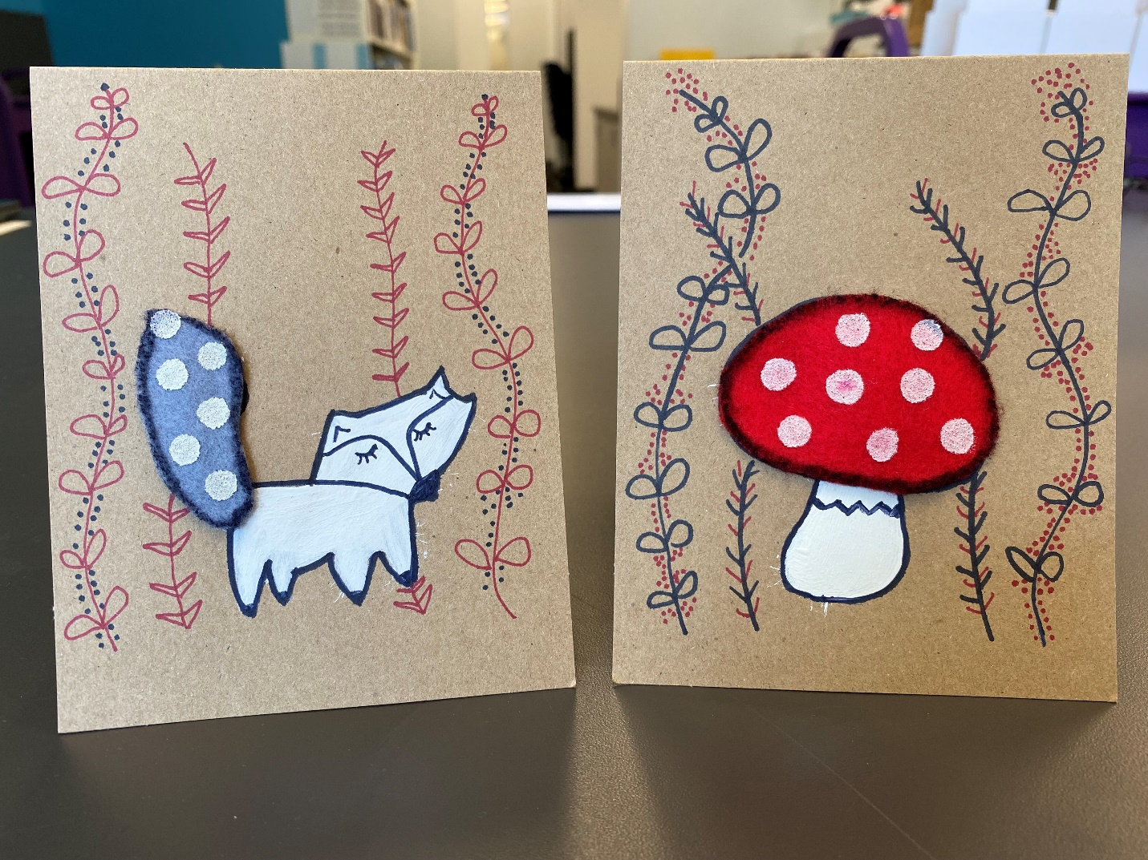

Overview
This project is for adults and children in third grade and up.

Materials
Included in kit
Card + envelope
Woodland cookie cutter
Toadstool stencil
Red felt
Grey felt
Black permanent marker
2-sided red permanent marker/fine tip point
Q-tip
Nylon hair paint brush
Container of white acrylic paint
Tacky glue

You’ll also need
Scissors
A pencil

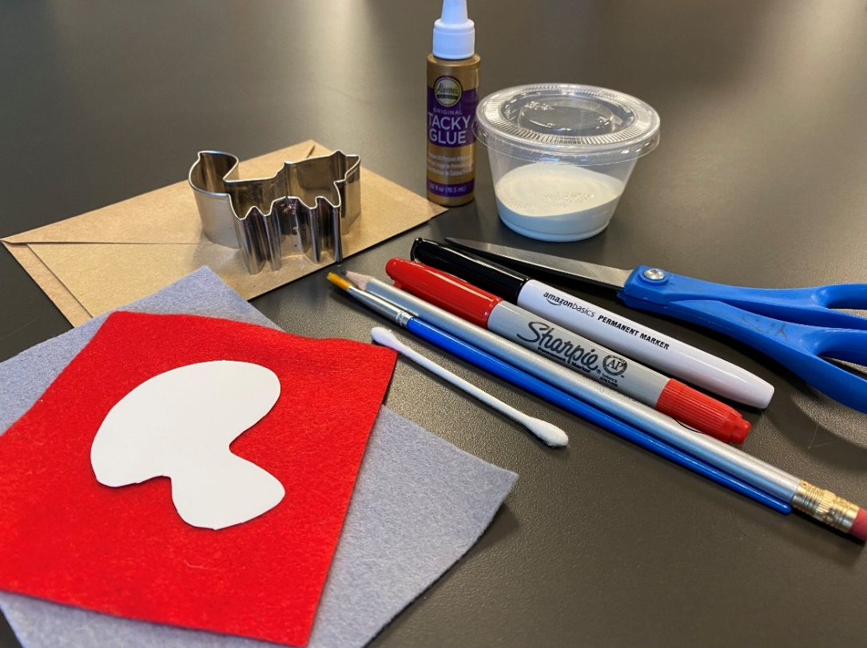

Instructions
- Place your cookie cutter on the card where you’d like to trace it. Trace the cookie cutter with a pencil.

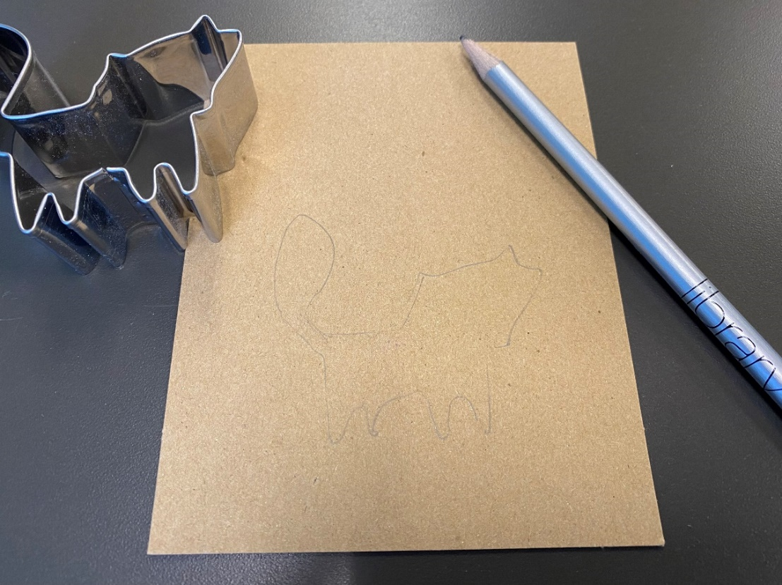

- Paint the inside of your outline with white paint, using your nylon hair paint brush.
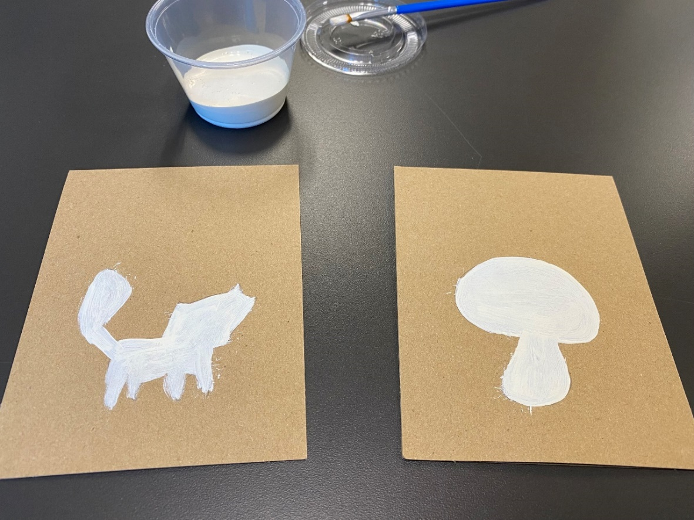

- Once the paint dries, use the black permanent marker to create a thicker outline.

- Use the cookie cutter to trace the shape onto your felt. Choose which part of the shape you’d like to accent with felt. Cut it out and place it on your card. If you’re happy with how it looks, use the tacky glue to glue the felt onto your card.
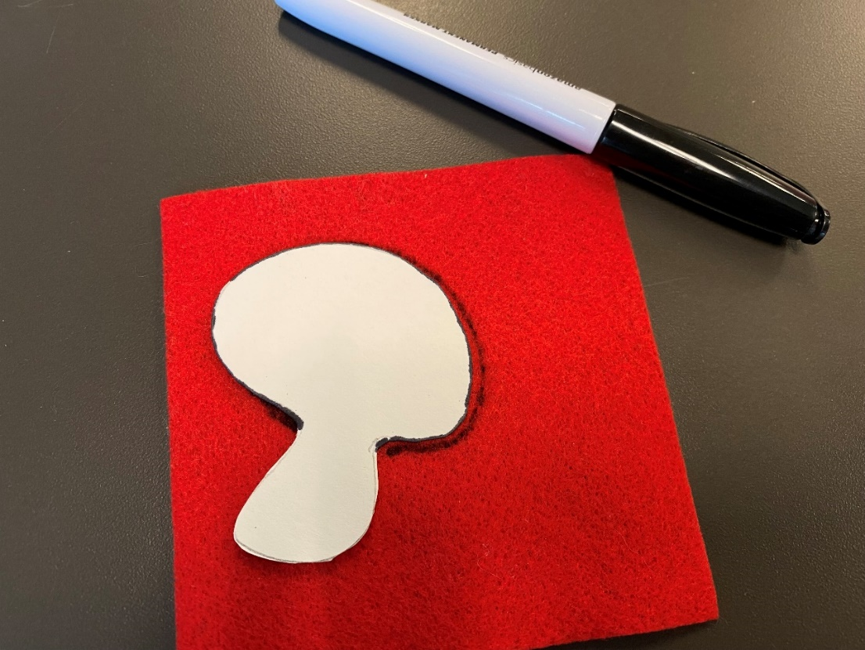

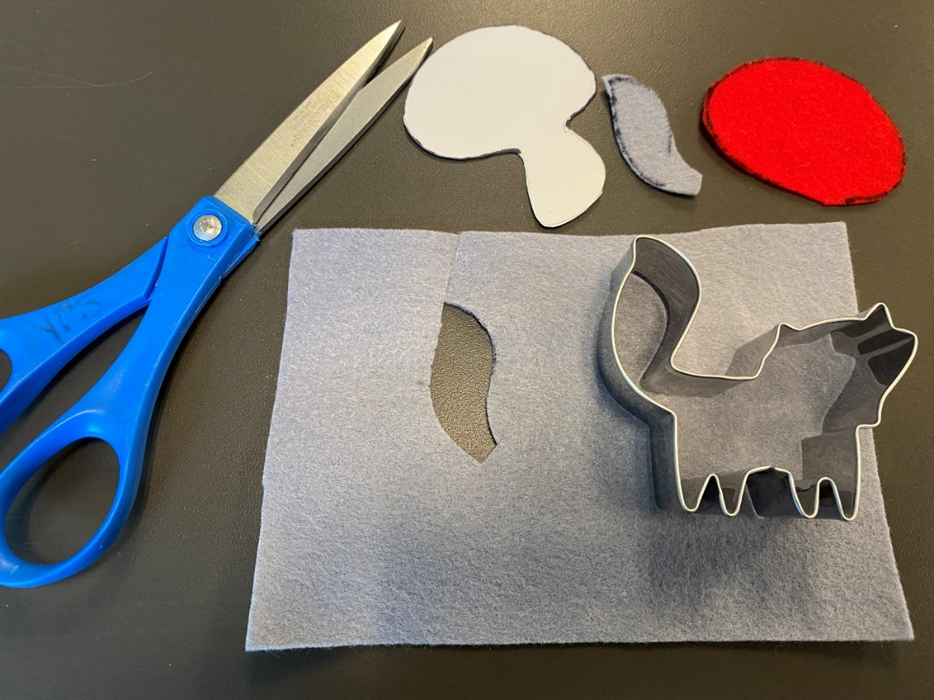
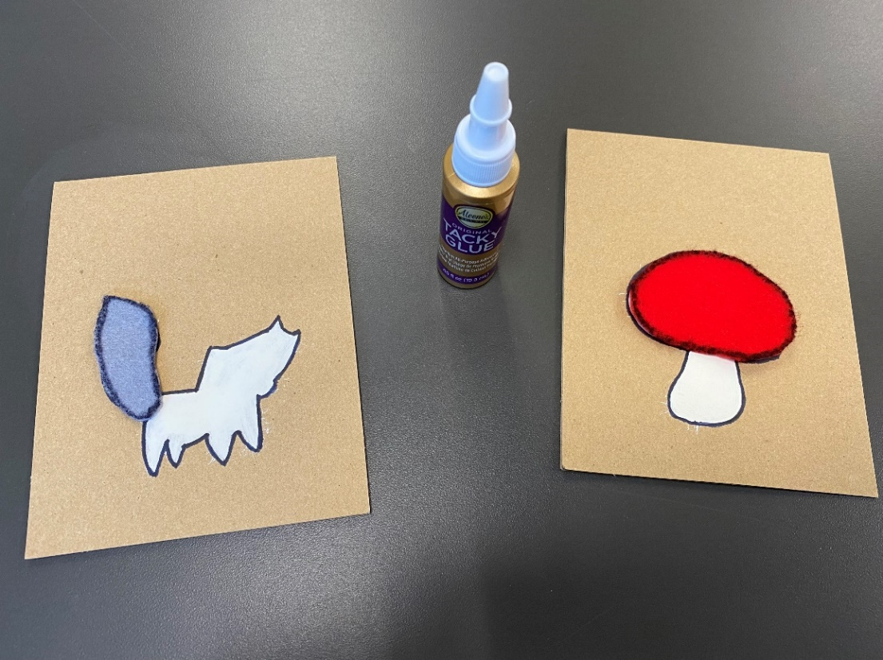

- Add any desired accents with the Q-tip and paint (e.g. if you made a toadstool and you’d like to add some polka dots to the felt, or snow in the background, etc.).

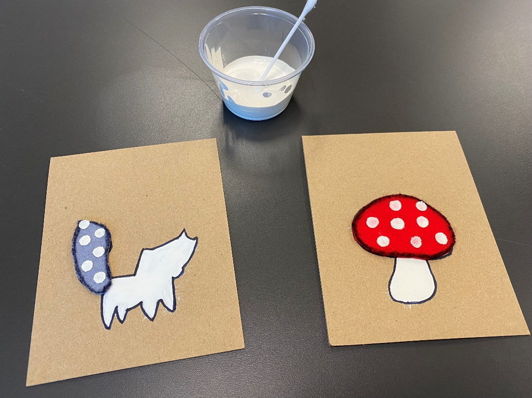

- Add any desired accents with your permanent markers (e.g. if you want to add a face to your creature, etc.).

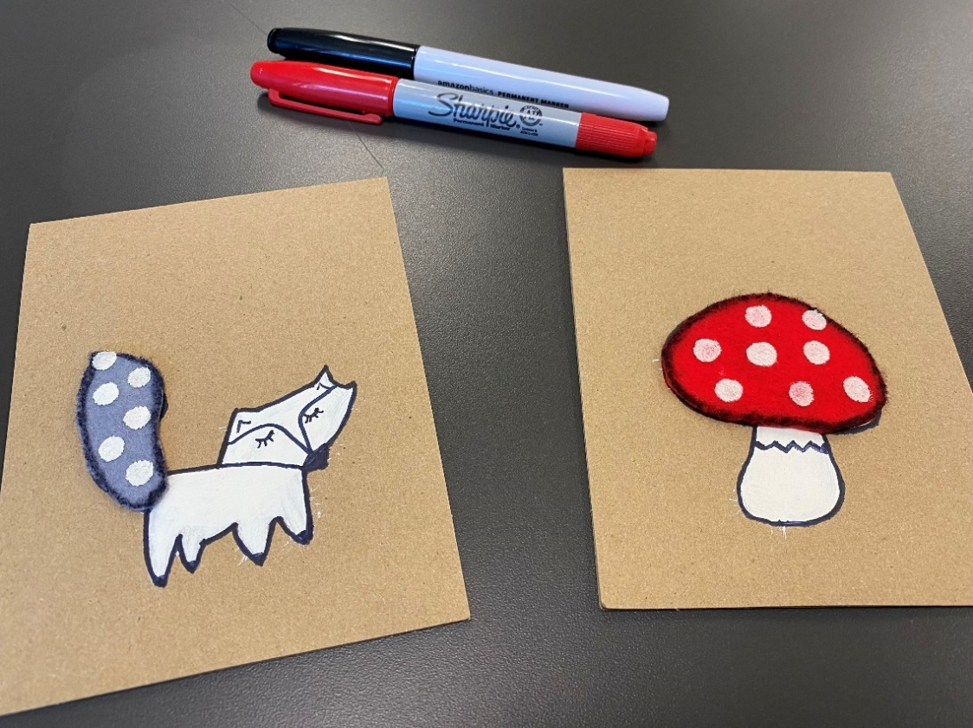

- Draw some vines and branches with leaves next to or around your woodland shape. You can alternate between the black and red permanent markers.
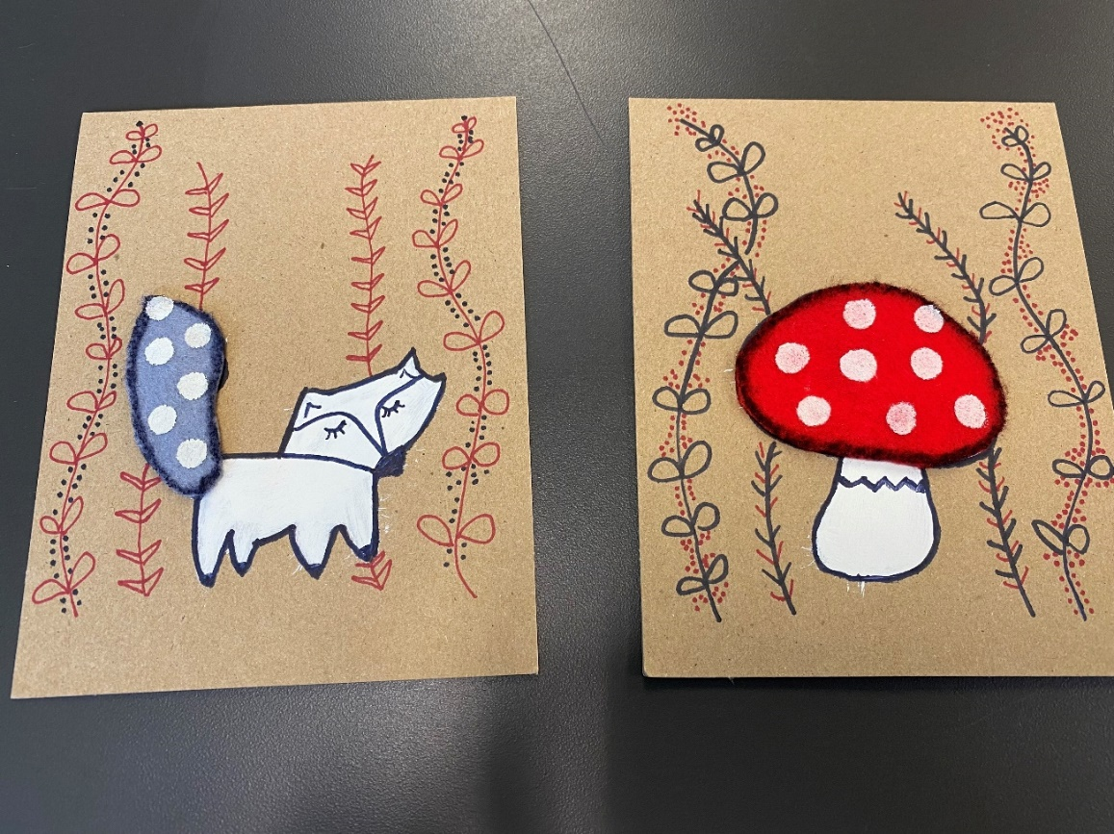

- Add some berries with your red permanent marker for a pop of color. You can even fill in some of the leaves on the vines with white paint if you’d like.
- You’re all set! Decide if you want to display your card in your home, or send it to a loved one.

