Snowflake Hoop Ornament

Overview
This project is for adults and children in third grade and up.

Materials
- White yarn
- Plastic sewing needle
- Piece of plaid fabric
- 3” embroidery hoop
- Length of twine

Instructions

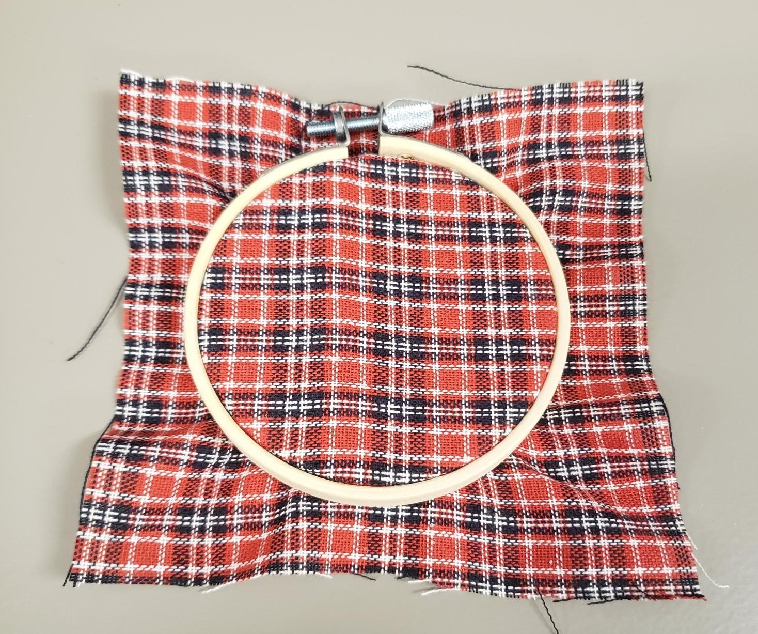
- Separate the two rings of the embroidery hoop. Lay the piece of fabric over the inner circle and place the outer ring over the top of the fabric so the two hoops are aligned. You may need to use the adjuster on the outer ring to adjust the outer hoop so that it fits over the fabric. When the outer ring is in place, adjust the fabric so that it is taught and without creases. Once the fabric is smooth and in place, you should tighten the hoop adjuster so that the fabric moves less during the project and may need to adjust the fabric throughout the project.

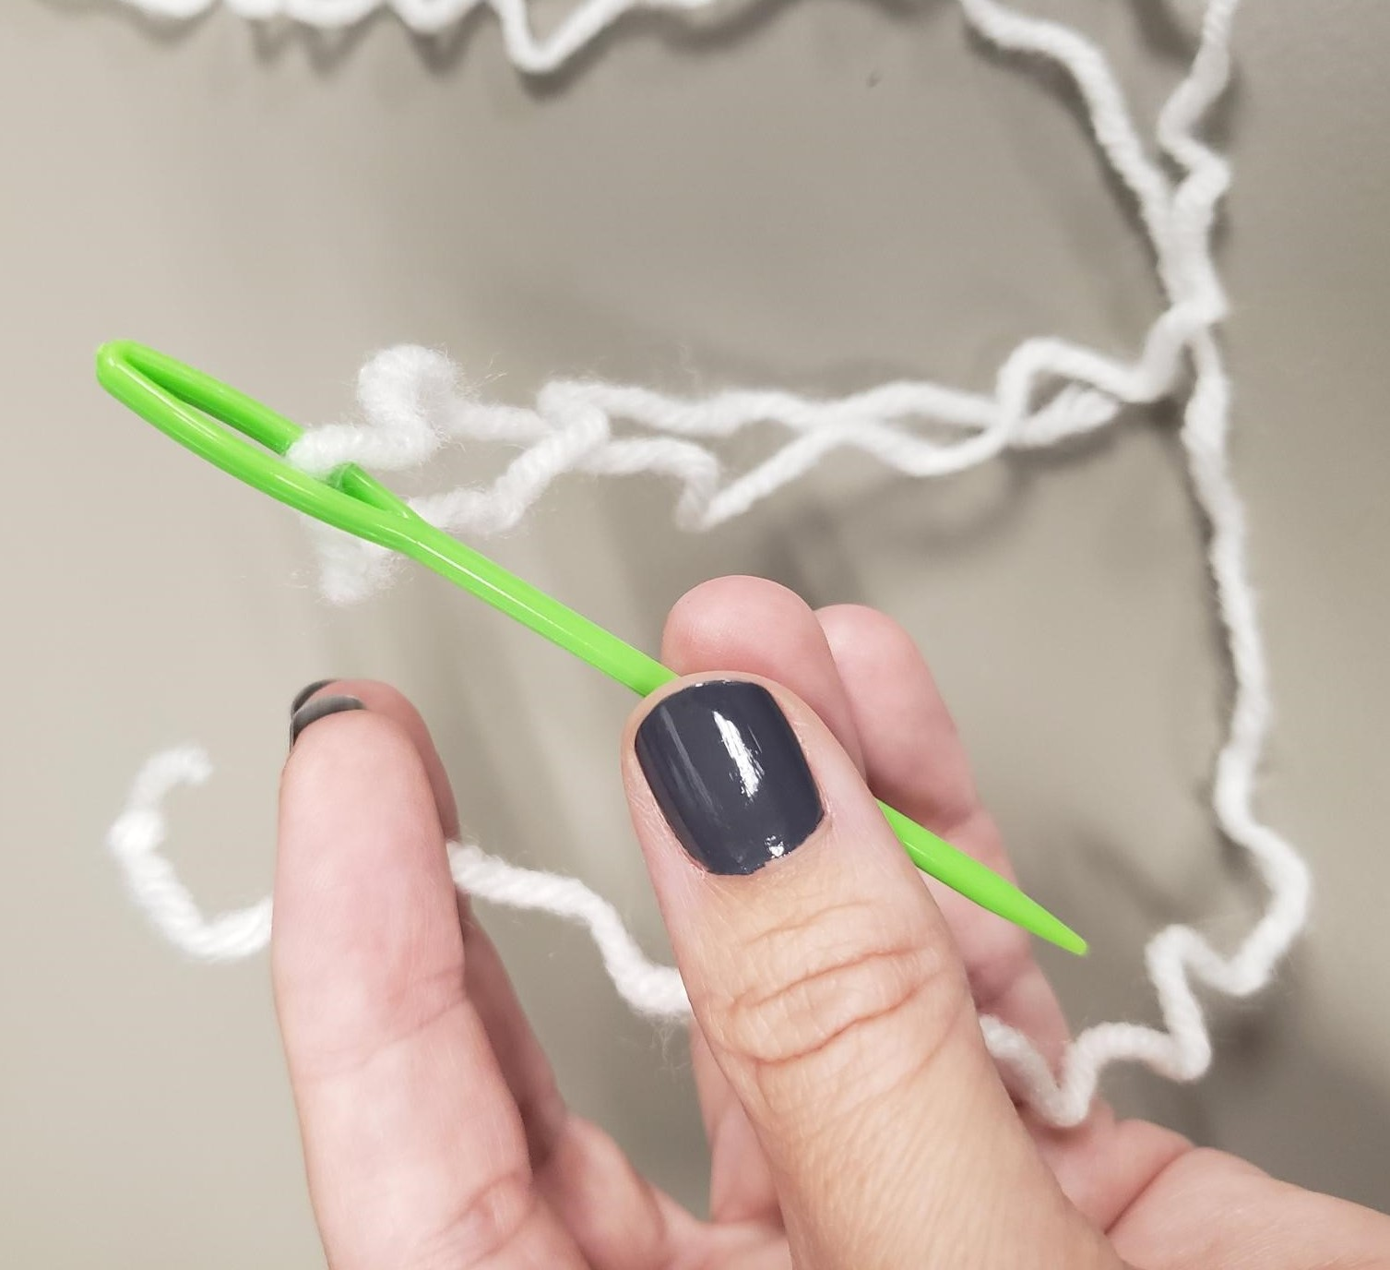
- Once your hoop is prepared, find the needle and yarn that are included in your kit. At one end of the yarn, tie a knot to prevent the yarn from being pulled completely through the fabric. After knotting one end, take the other end of yarn and thread it through the eye of the needle.

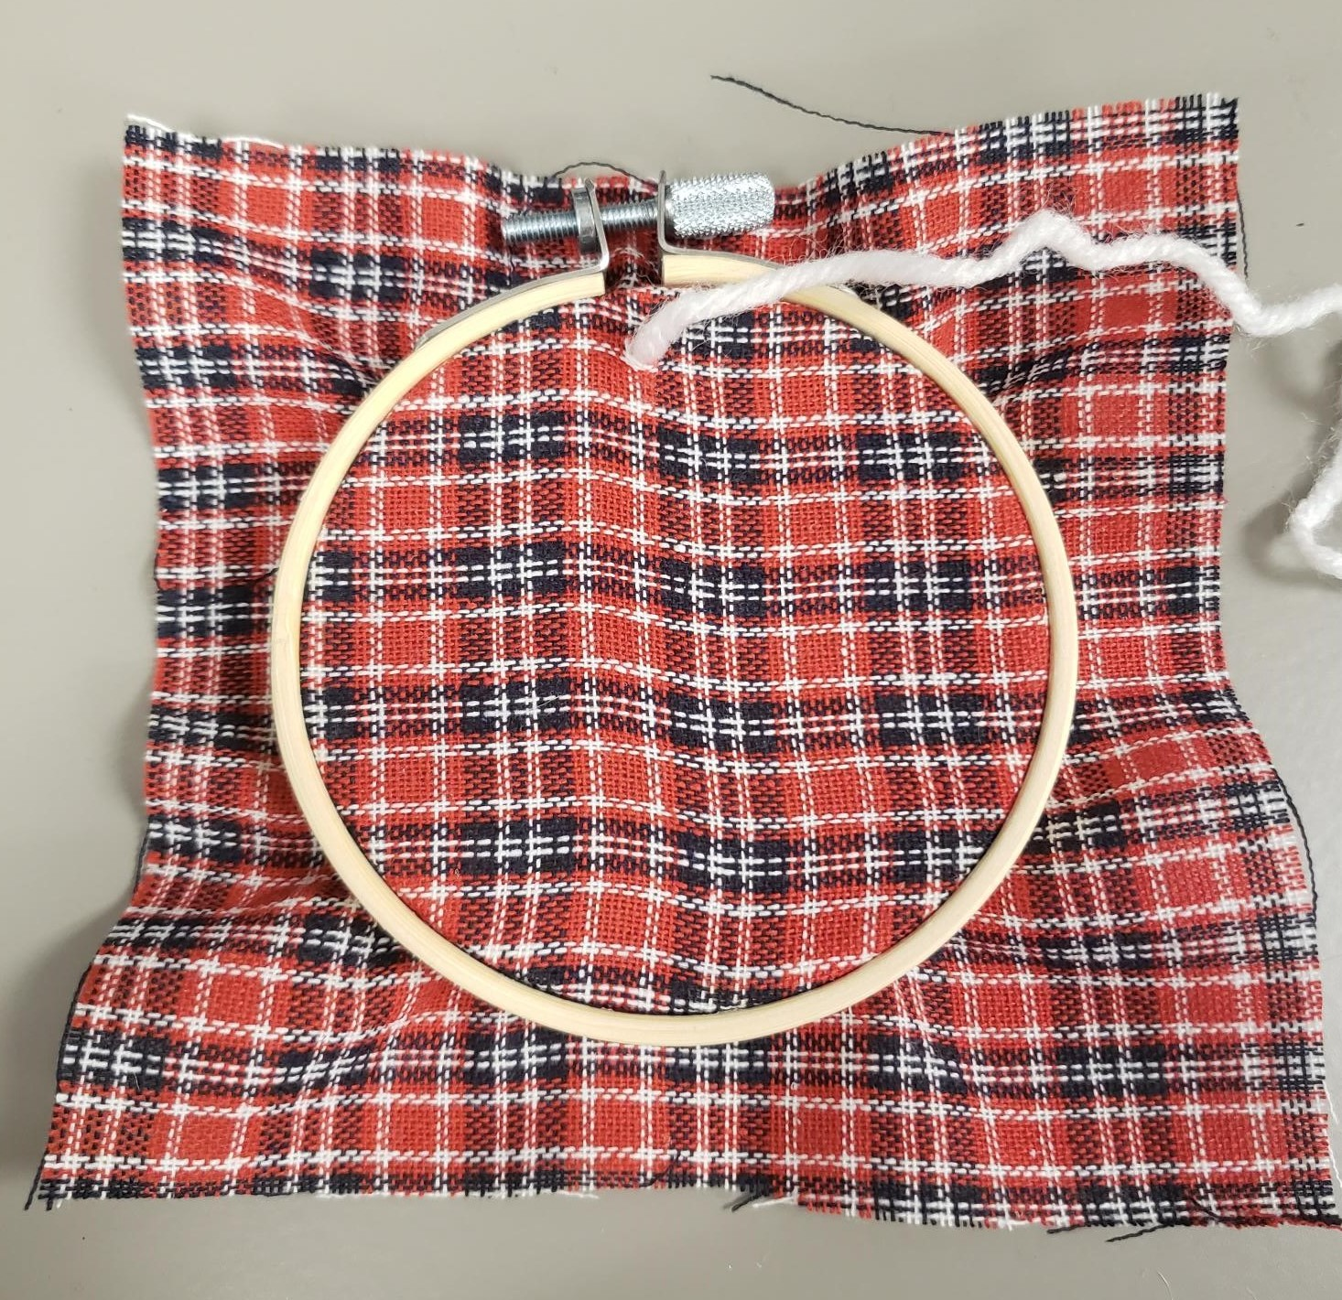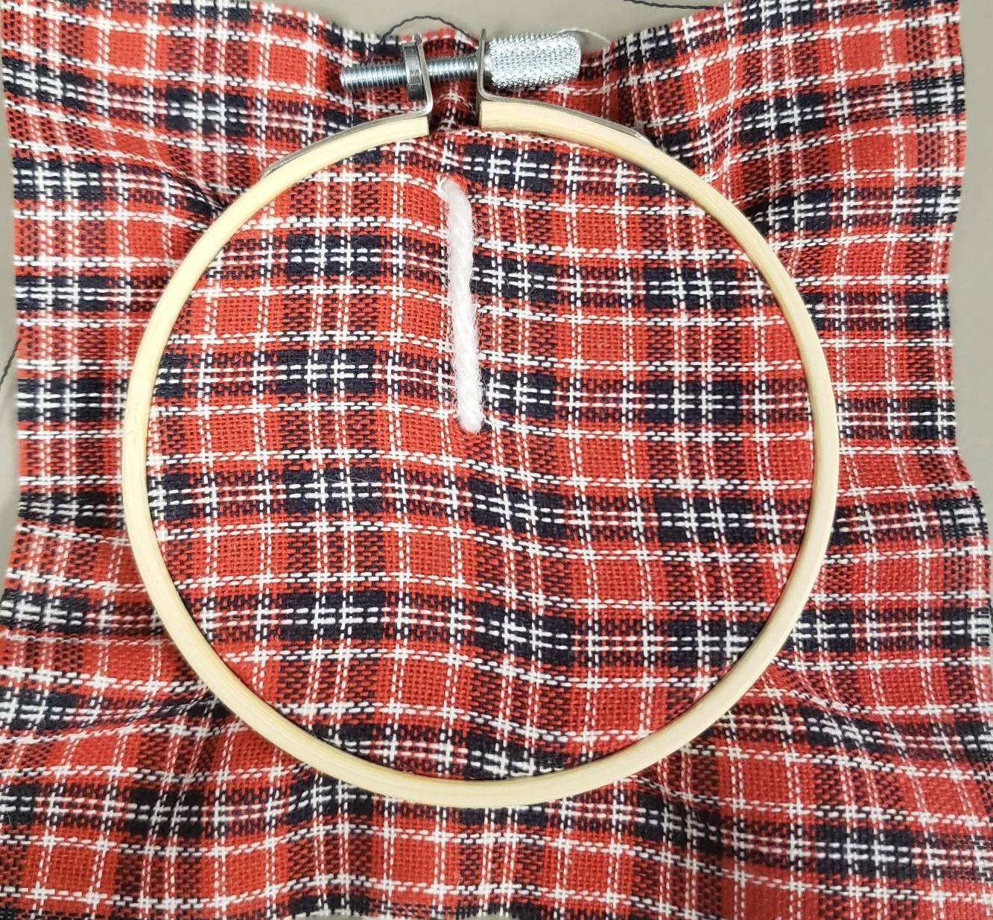
- With your materials prepared, take the needle and position it so that it is directly under the hoop adjuster. Push the needle through the back of the fabric so that the knot is on the backside of the hoop.
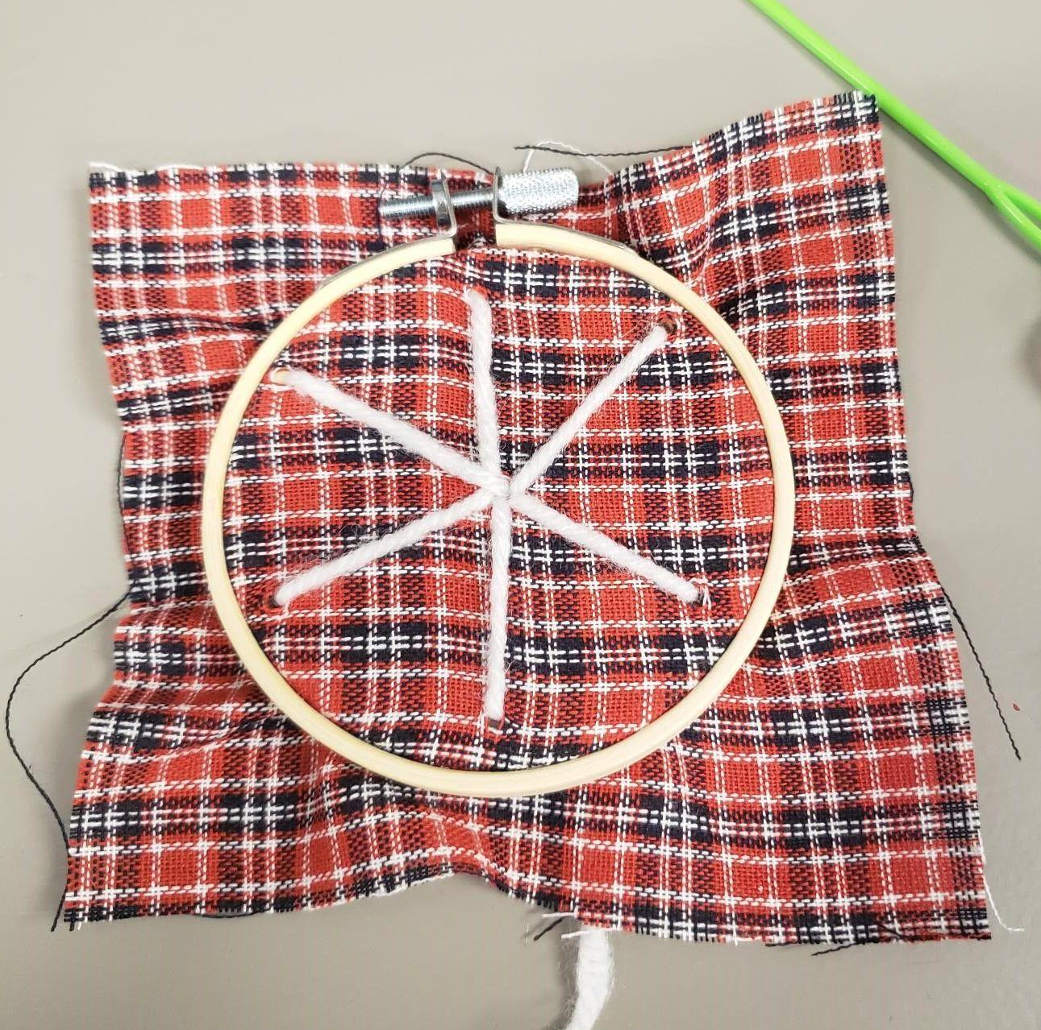

- Bring the needle to the center of the circle and push the needle/yarn through. Continue this step 5 or 6 times, until branches are evenly spaced around the circle. Once your main snowflake branches are stitched onto the fabric, you can begin to start adding in smaller branches where you would like. Creating a series of up and down arrows at the top of the branches and in the middle will help to give your snowflake character and definition.
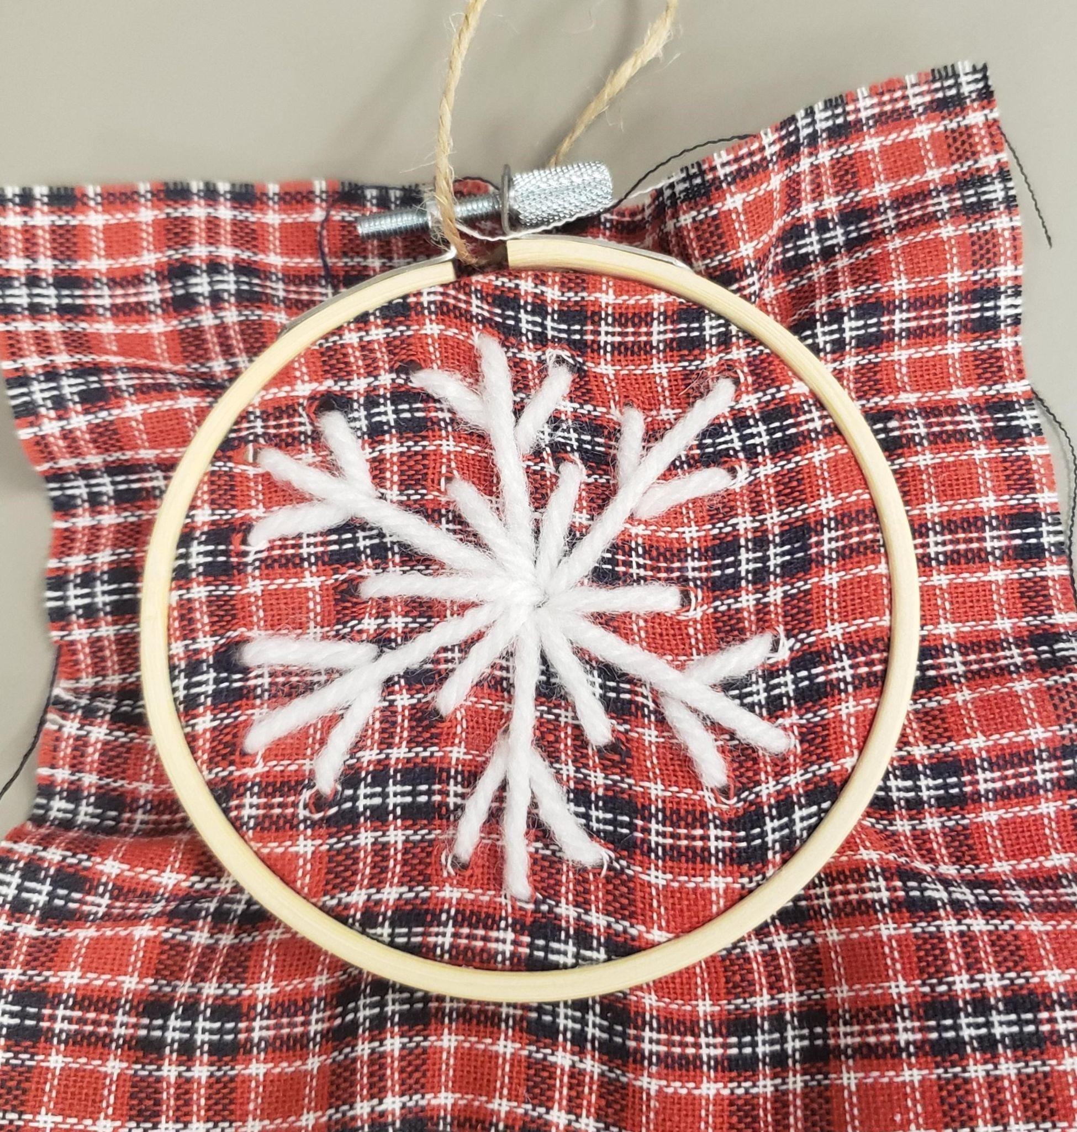
- After adding the small branches to your snowflake, you will want to tie off the end of your yarn so that it does not unravel. The knot should be on the backside of the hoop.

- Once your hoop is finished, you may trim some of the excess fabric off the hoop or leave it as is. You should take the piece of twine from your kit and use it to tie a loop at the hoop adjuster. This will allow you to hang your hoop ornament. After this, your project is complete.

