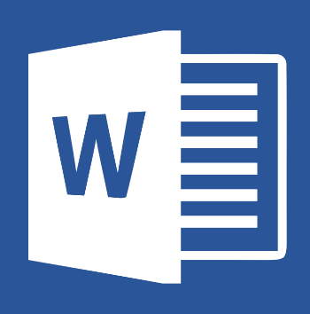
Microsoft Word 2016
Document Outline
- What is Microsoft Word?
- Open Word and Create a Document
- Important Terms
- Components of the Interface
- Text Entry and Formatting
- Page Layout
- Using Rulers and Tab Stops
- Saving
- Additional Resources

What is Microsoft Word?
Microsoft Word is a word processing program used for creating professional-quality documents, reports, letters, resumes, and more. It has features beyond a plain text editor, such as formatting, spell and grammar checks, and advanced page layout options. It is part of the Microsoft Office Suite, which also includes Excel and PowerPoint.
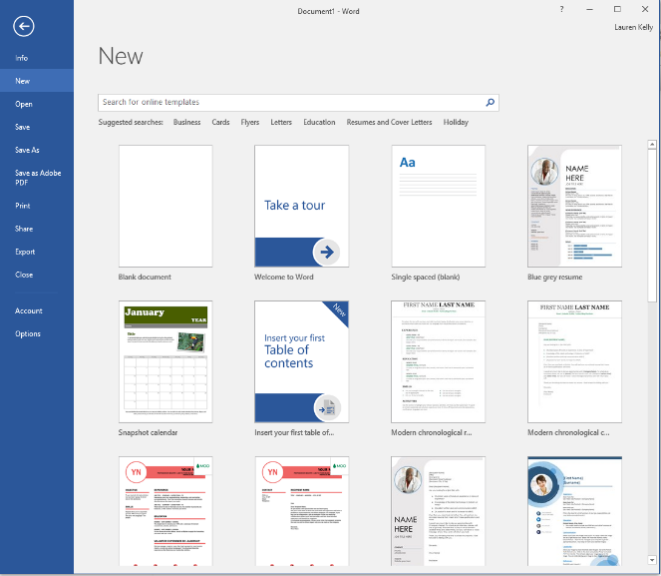
Open Word and Create a Document
To open Microsoft Word, click on the icon, which looks like the image above (blue W over lines). This might be found in the taskbar at the bottom of the screen, as a shortcut on the desktop, or in the “Start” menu (bottom left of the screen). Applications in the “Start” menu are arranged alphabetically.
Upon opening the application, you will be asked to open a new document. You can choose “Blank Document” (the most common choice), or work from a provided template. Templates are useful for resumes, brochures, invoices, reports, and more. Finally, there is the option to choose a tutorial. These are learning modules provided by Microsoft, which show basics and provide examples.

Important Terms
- Document– The active workspace in Word.
- Header and Footer – The header is the top margin of a page, the footer is the bottom margin of the page.
- Rulers – Located at the top and side of the document, the rulers show the measurements of where text appears on the page. Rulers also let you control the margins of the page and indentations of paragraphs.
- Cursor – The cursor is the blinking vertical line that shows where typed text will appear.
Components of the Interface
- Title Bar – The uppermost row of Word, which contains the title of the current document. The default title is “Document1”. In the top right corner, Minimize, Maximize / Restore Down, and Close can also be found.
- Ribbon – Above the document is a section of command tabs called the Ribbon. A multitude of options are found behind each tab of the ribbon. The available tabs are:
  - File – Saving, Printing, Exporting, and Opening a new document, etc.
  - Home – Where the most frequently accessed features live, such as formatting
  - Insert – Adds content beyond text to the page (pictures, charts, headers, footers)
  - Design – Contains themes and pre-made document formatting options
  - Layout – Changes how the page prints (margins, indentation and spacing)
  - References – Allows the addition of a Table of Contents, Footnotes, and Citations
  - Mailings – Contains options to design elements that will print on envelopes and labels with specific recipients. Mail Merge tools are contained here.
  - Review – Spell check, Thesaurus, and the tool to add comments are found here
  - View – Changes how the page appears digitally, including changing the view, and zooming in.
- Page View – Found at the very bottom of the Word window. Page View allows you to see how many pages are in a document zoom in and out, as well as different ways to display the document.
Text Entry and Formatting
Upon opening a new Word document, you can type to add text and numerical information to the page. Once text has been entered, it can be formatted to look a certain way. We will start to try out some formatting options listed below.
- Font, Text Size, and Color – Text can be changed to be many different type faces, found in the top of the screen under the “Home” tab. Size can also be altered. Text can be turned a different color, highlighted, and can also be bolded, underlined, and italicized. Both text and highlighting can have color applied.
- Bullet Points and Lists – Lines of text can be made into bulleted or numbered lists. Place the cursor at the beginning or end of a line of text and click the option you want. To change more than one line, select the information and then click the icon.
- Alignment – Text can be aligned to the left, center, or right of the page. Text can also be justified to be aligned with both margins.
- Styles – Pre-made formatting styles, such as headers, titles, and subtitles are available to use. These can be handy when a document has multiple sections.
Page Layout
There are many options for how to layout text in Microsoft Word beyond the simple alignment tools in the “Home” tab. Many more are found in the “Layout” tab.
- Margins and Columns – The default margin layout of a page is 1 inch all around the text. Margins can be changed to other options, including custom.
- Indentation – It is customary to indent the first word of a paragraph, as well as text in bullet pointed lists. You can change the indentation settings for individual lines, or the whole document in the “Layout” tab.
- Spacing – This refers to the spacing between lines. It can also be changed by line, or to apply to the entire document.
Using Rulers and Tab Stops
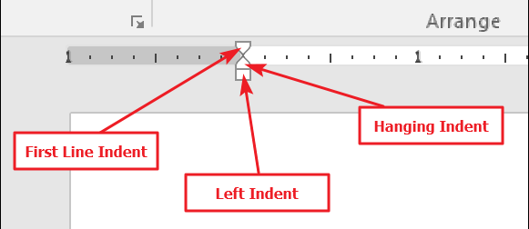
Manipulating the rulers at the top and sides of the document gives additional control over margins and indentation. The white space of the ruler shows where text will appear. The grayed out area represents the margins. There are triangle and box shaped markers that allow control for the indenting of individual paragraphs.
The box, called “Left Indent” changes the indentation for all lines of a paragraph. As you slide it, the other two indent markers move as well.
The top triangle is called “First Line Indent,” which just changes the indentation for the first line of the paragraph.
Finally, the bottom triangle, called “Hanging Indent,” changes indentation of all lines except the first line.

Tab Stops are another tool useful for controlling indentation. A tab stop is the location your cursor moves to when you hit the Tab key. A default Word document has no tab stops, so each time you hit the Tab key, the cursor jumps ahead about eight characters. Setting tab stops lets you better control and line up text. There are many tab stop options, but the most common and simple is “Left Tab Stop” which looks like the letter L. This one is used most of the time.
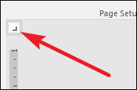

To insert a tab stop, just use the button to select the type of stop you want. Now, point your mouse anywhere on the white portion of the horizontal ruler (toward the bottom of the ruler line), and then click. A symbol appears indicating the type of tab stop you’ve placed. This is a tab marker, showing where the text will jump to if you press the Tab button on your keyboard.
Saving
Saving – The first time that you save a document, you will also be given the option of naming that document. The Save function is located in the File tab of the Ribbon menu. Click on the File tab and then navigate to where it says Save. A pop-up box will then appear. Type the name in the File name box. You can also choose the file type. Word Document is the most common.
Save your progress often while working in Word by clicking Save. This will overwrite existing progress. To create a new version, choose Save As.
Additional Learning Resources
Lynda.com is an online learning platform that provides free, professional learning videos for BAL cardholders. Login with your library card and search for “Microsoft Word” for relevant video tutorials. The login page is linked here: http://bit.ly/2FMk4zJ
If you would like further assistance from our staff, you can make a 1:1 appointment through our website with this link: http://bit.ly/2IuHr2k

