December Booklist | BALibrary Staff Favorites

FICTION
Beautiful World, Where Are You? by Sally Rooney
Big Fish by Daniel Wallace
The Curious Charms of Arthur Pepper by Phaedra Patrick
Farewell, My Lovely by Raymond Chandler
The Girl with the Louding Voice by Abi Dare
The Keeper of Lost Things by Ruth Hogan
Lonesome Dove by Larry McMurtry
The Marriage Code by Brooke Burroughs
Minor Dramas & Other Catastrophes by Kathleen West
Mr. Nobody by Catherine Steadman
Moonflower Murders by Anthony Horowitz
“A Perfect Day for Bananafish” from Nine Stories by J.D. Salinger
Piranesi by Susanna Clarke
The Push by Ashley Audrain
Random Harvest by James Hilton
The Seven Husbands of Evelyn Hugo by Taylor Jenkins Reid
Things in Jars by Jess Kidd
Very Sincerely Yours by Kerry Winfrey

NONFICTION
The Comfort Book by Matt Haig
Complete Container Herb Gardening by Sue Goetz
Crying in H Mart by Michelle Zauner
Start by Believing by John Barr
The Year of Less by Cait Flanders

YOUNG ADULT
All the Stars and Teeth by Adalyn Grace
Clap When You Land by Elizabeth Acevedo
Eleanor & Park by Rainbow Rowell
The Marrow Thieves by Cherie Dimaline
Punching the Air by Ibi Zoboi

About MakerLab

Located on the first floor in the Business & Technology Center, the MakerLab gives Barrington Area Library cardholders access to a variety of cutting edge tools including 3D printers, a laser cutter, CNC machine, and vinyl cutter. The purpose of MakerLab is to provide space for customers of all ages to learn through making, using skills such as math, art, and design thinking, to complete self-driven projects. Staff are available by appointment to help develop a plan to make your work possible, but it should be noted that MakerLab is not a substitute for a full-scale production facility and limitations on materials and quantity may apply.

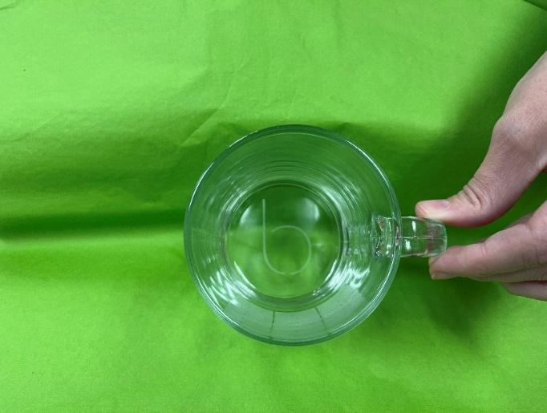
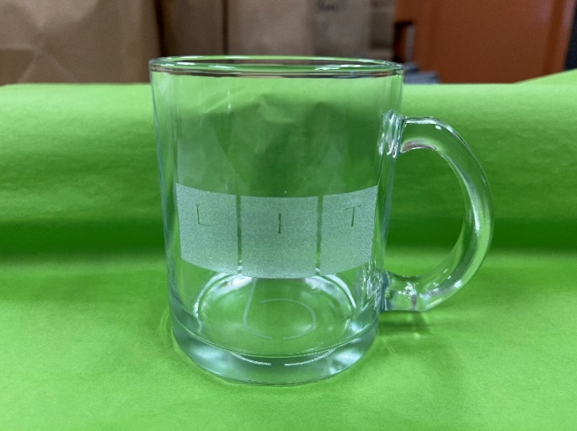
If you are interested in learning more, visit www.balibrary.org/makerlab or contact digitalservices@balibrary.org.
This glass mug was etched using the laser cutter in the MakerLab.

Welcome Back, Seed Library!

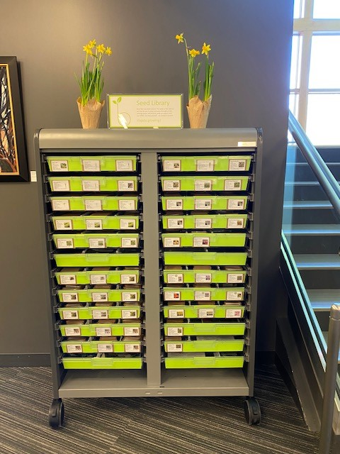
Stop by on Tuesday, February 1 to see what we’re offering in the Seed Library this season. During the day, our Master Gardener experts will be on hand to answer questions and share seed starting tips. Learn how to create a custom plant stake with the laser cutter, and pick up take and makes for both kids and adults too. While supplies last. Seeds are organic and non-GMO.
