Creativebug
Document Outline
- Getting Started
- Navigating
- Taking a Class
- My Account
- Conclusion

Getting Started
What is Creativebug?
Creativebug is a database of high quality craft and hobby classes that is offered to you for free through the library. Like YouTube, you can search for the craft you’re interested in and then watch a video (or rewatch, as necessary) to learn along with the presenter. Unlike YouTube, these videos are high quality, with helpful PDFs that you can download for material sheets, instructions, or patterns. You can watch as many videos as you want, as many times as you want, any time you want. Your account will keep track of what you’ve watched for you, so there’s no need to try to remember how you found the video.

Finding Creativebug
The first thing you’ll do is go to BALibrary.org. At the menu on top, click on “databases.”
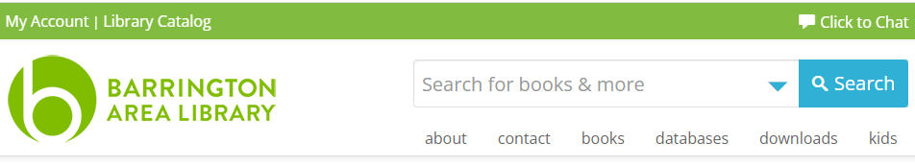

All the databases are listed alphabetically. Scroll to the C’s and click on Creativebug.

Creating a Login
If you’ve never logged into Creativebug before, you will need to create a login. If you have created a login, you can simply click the “log in now” option. Otherwise, follow the prompts to sign up.
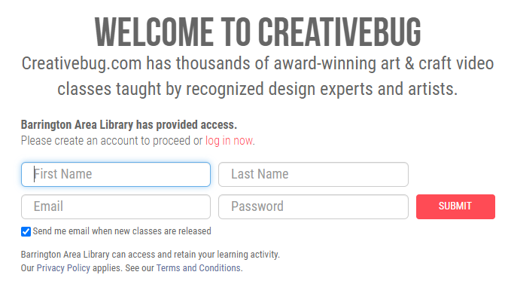

Navigating Creativebug
When you log in, you’ll notice there are 4 key options at the top for navigating Creativebug: Classes, Daily Practice, Resources, and the Search bar.
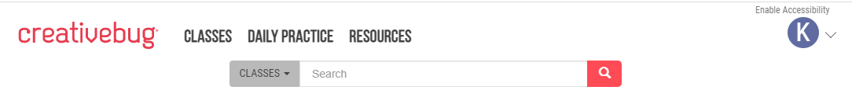
Classes
Classes are the videos you can watch. If you hover your mouse over the Classes option, you’ll see categories appear below. Hover over a category and subcategories will appear below that. It also gives you a great place to start if you select “For Beginners” or “Quick Classes”. While painting, sewing, and paper crafts sound typical for what you might expect with a database like Creativebug, the subjects that surprised me were under Food+Home: Baking & Cake Decorating, Bath & Body, Canning, and Flowers (Gardening).

Daily Practice
Daily practice is a page with creative prompts to get your creative juices flowing. There are various series to choose from, each geared toward different forms of creating: abstract art, sewing, stamping, painting, drawing, and more!

Resources
As with Classes, you can hover over Resources and see different categories to choose from. Many of these categories are self-explanatory, but there is one that many patrons have found to be very helpful. The one I will focus on for this introduction is the Pattern Library. It has a collection of crochet and knitting patterns that you can download and use for yourself. Some have videos, some don’t, so feel free to explore and share with others!

Taking a Class
To take a class, all you have to do is pick anyone you want! Whether searching for something specific or browsing to see what’s out there, simply click on the video you want to watch when you find something interesting.

Search
Using the Search bar at the top, you can enter in keywords and hit the Enter key on your keyboard, or click the pink magnifying glass on the right side of the bar. But, like most searches, you might need to try a couple of different words before you find what you’re looking for. If I search “cat,” it gives me everything that has a cat in it. If I search “crochet cat,” it gives me a cat I can crochet, but also everything related to crochet.

Key Features of a Video
Creativebug videos give you similar options to any online video. You can play/pause, rewind 10 seconds, move the slider to go ahead or back, view it in full screen, and add captions. Creativebug labels their crafts by skill level, which is helpful for both beginners and crafters looking for something more advanced.
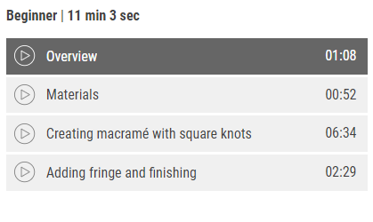
Classes are also broken up into different sections so you can go immediate to the part you want. For example, there is a materials list in the description of the video, but make sure to watch the materials part of the video as well because often times, the creator will make a specific comment about the material they are requiring for the craft, such as what to look out for when purchasing.

The Meaning of Time
Videos on Creativebug will tell you how long they are, but don’t mistake the time of the video for the time of the craft. I recommend watching the class all the way through first so you know everything it will entail.
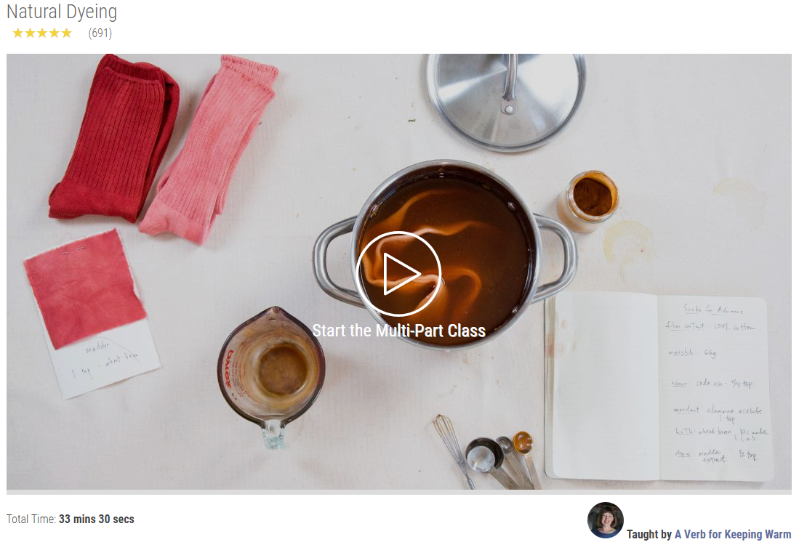
Looking at this Multi-Part Class for Natural Dying, it shows at the bottom that the Total Time is 33 minutes and 30 seconds. However, if you watch the video, part of the dying process is letting things sit for hours.

PDF Attachments
Creators attach PDFs to their videos for users to download and keep for themselves. These PDFs might only be a materials list, or, in the case of sewing or knitting, it can also include a pattern for you to use.

Comments
The last thing I would recommend you look is the comment section at the bottom. This is where people can comment praise or questions. I like to look for any questions that people have asked because this might be something I will run into when I am trying the craft for the first time.

My Account
Your account will keep track of all your videos you’ve watched! To access it, go to the top right of your screen and click on the circle with your first letter in it.
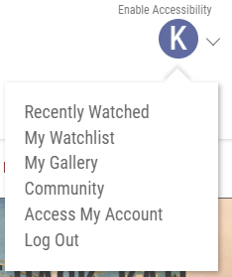
This will give you a drop down of options to pick from. By clicking “Recently Watched” you can see a list of videos you’ve looked at previously. My Watchlist is where you’ve saved videos to watch later. My Gallery is where you can put pictures of things you’ve made to remember them and share with others.

Conclusion
Creativebug is a fantastic database for beginner and seasoned crafters alike. It breaks down crafts in a way that make it approachable if you’re hesitant to try something new. With videos and series added regularly, you’ll always find something new to explore. To get the most out of Creativebug, I encourage you to look around and try things out. You’ll never know what you’ll stumble upon.

