Introduction to Tinkercad
Document Outline
- Getting Started
- Help
- Dashboard and Workplane
- Designing
- Build Something
Tinkercad
Tinkercad is a free online program that has many different uses, but for today’s class, we will be using it to learn how to create our own 3D printed objects.

Getting Started
I will first walk you through how to get signed up for Tinkercad. It’s free and easy to use! In the future, you’ll be able to log in, but for today:
- Go to Tinkercad.com
- On the top right of the homepage, click on the button that says “Sign Up”
- Under “On your own,” click on “Create a personal account”
- Click on “Sign up with Email”
- Enter your birthday and click “Next”
- Enter your email and create a password that you will remember
- Once checking the box to agree to the terms of use, click “CREATE ACCOUNT”

Help
Before looking at designing, let’s look at some resources available to you to help you learn.
- At the top, click on “Tinker,” and then “3D Design”
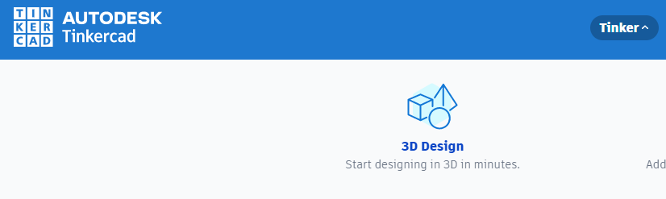
- As you scroll down, there are so many resources and tutorials that can help you if you get stuck
- Under “Get Started,” there are a bunch of tutorials to help you learn new skills with designing your 3D prints
- Things to consider when creating a 3D print:
  - The more intricate, sometimes the harder to print
  - Supports will be needed to print anything with an overhang

Dashboard and Workplane
Your dashboard is where you will end up when you log in and it will show you the files you’ve already created. From here, you can create a new 3D design on a design space called a Workplane.
- From the 3D Design page, click on “Start Tinkering”
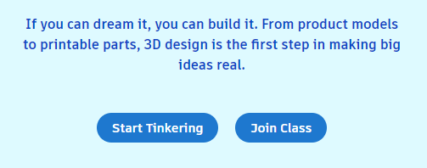
- On the right-hand side, click on “+ New” and then “3D Print” in the menu that drops down
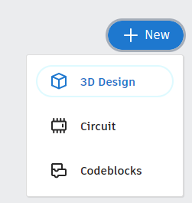
- Menu on the Left
  - Home view
  - Fit in view
  - Zoom In
  - Zoom Out
  - Switch to Flat View/Perspective
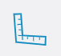
- Menu on the Right
  - Ruler
  - Notes
  - Shapes Library

Designing
Now, we will go over basics on designing in the Workplane.
- Placing shapes
- Aligning
- Grouping
- Making Holes

Build Something!
Build a house by:
- Placing a cube with the measurements of 2 inches wide, 2 inches deep and 2 inches tall
- Add a roof that is 2 inches wide, 2 inches deep, and 1 inch tall
- Add a rectangle for a chimney that is .25 inch wide, .25 inch deep, and 1 inch tall, then place it in the roof
- Hold down shift and click on each object to select them all
- Click on Group to combine them
- Click Export on the top right and select .STL
- Congratulations! You have designed your first 3D object!

