Yarn Birds
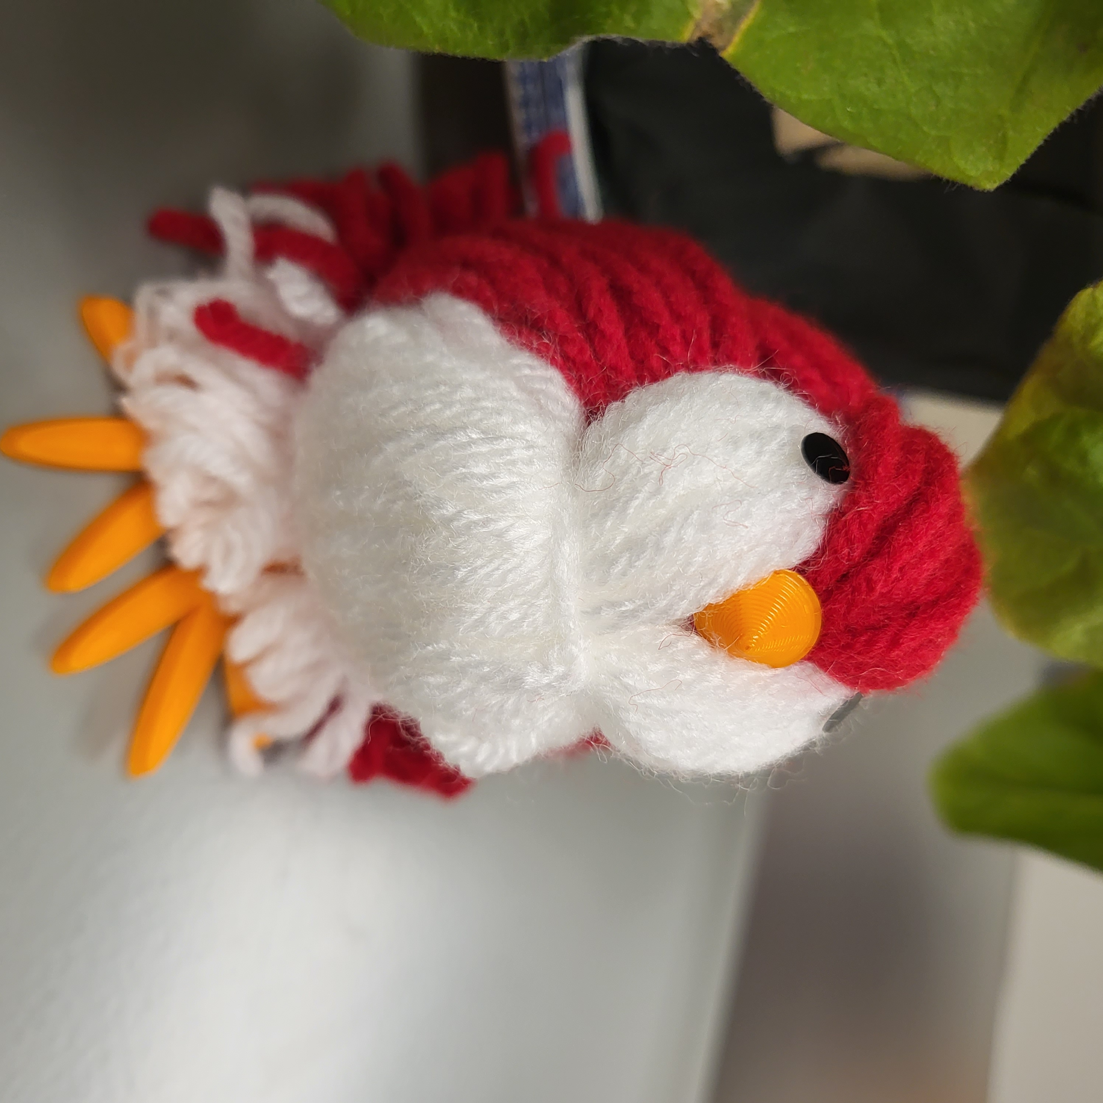Materials
- Yarn Bundles
  - 2 Red
  - 1 White
- Newspaper
- Scissors
- Tacky Glue
- 3D Printed Beak
- 3D Printed Legs
- 2 Vinyl Eyes

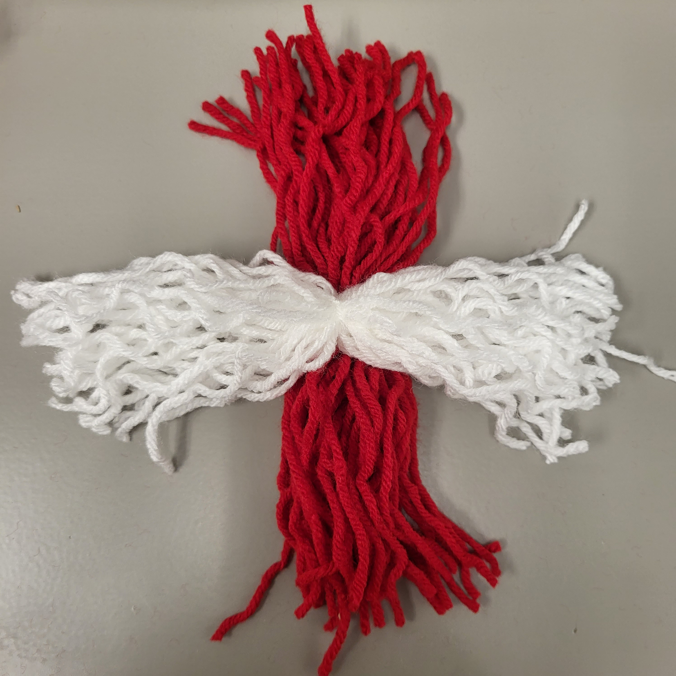
Make It!
- To start, pull one string of yarn out of each of the bundles to be used in Step 4.

- With the red and white bundle, place them one on top of the other, crossing in the middle.

- 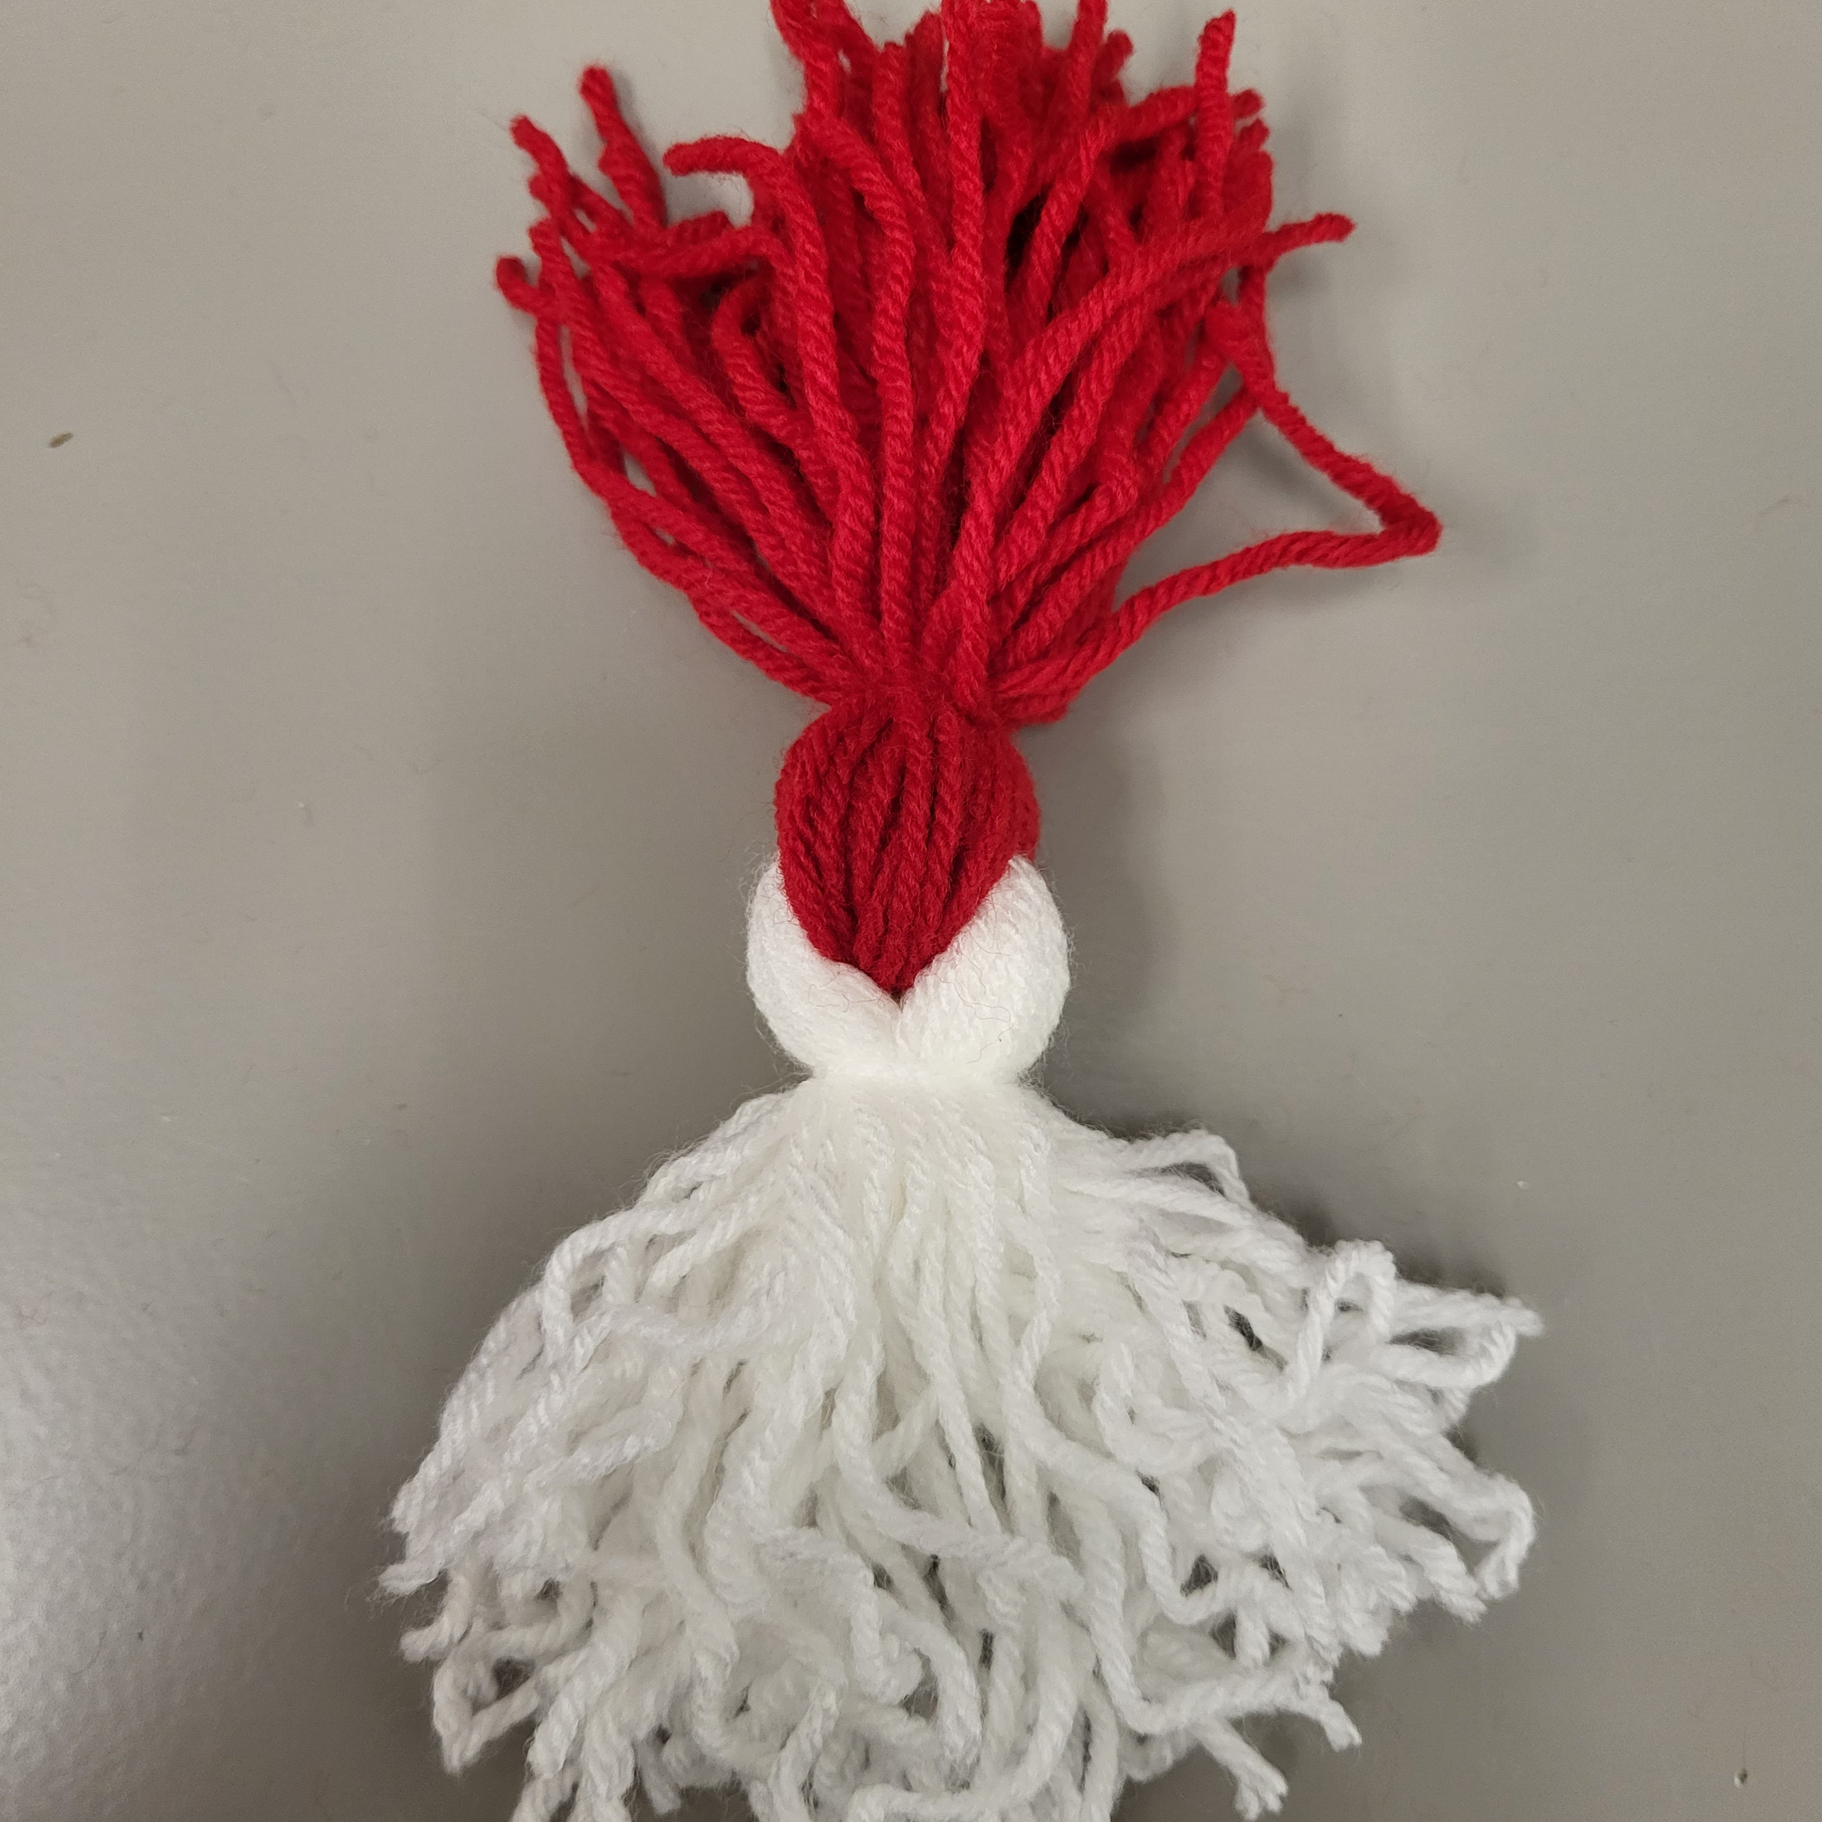Wrap both bundles of yarn around each other while keeping the centers connected. Pull them tightly on opposite sides.

- Using the yarn you pulled from the bundles in Step 1, tie a knot around each side as close to the center as possible. This creates a tight circular shape in the middle, which is the head of your bird!

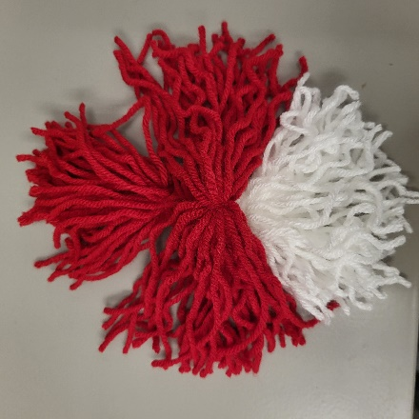

- Place the second red bundle on top of the two large yarn bundles. Make sure it is centered and perpendicular to the tied bundles from Step 4.

- Crumple a piece of newspaper and place it on top of the yarn bundles, right in the center.

- Your bird is about to take shape! This part required patience. Pull all of the yarn around the crumpled paper while keeping everything centered. Hold all the ends together to secure the paper inside the yarn. The bigger the paper, the bigger the bird, and the bigger the struggle.

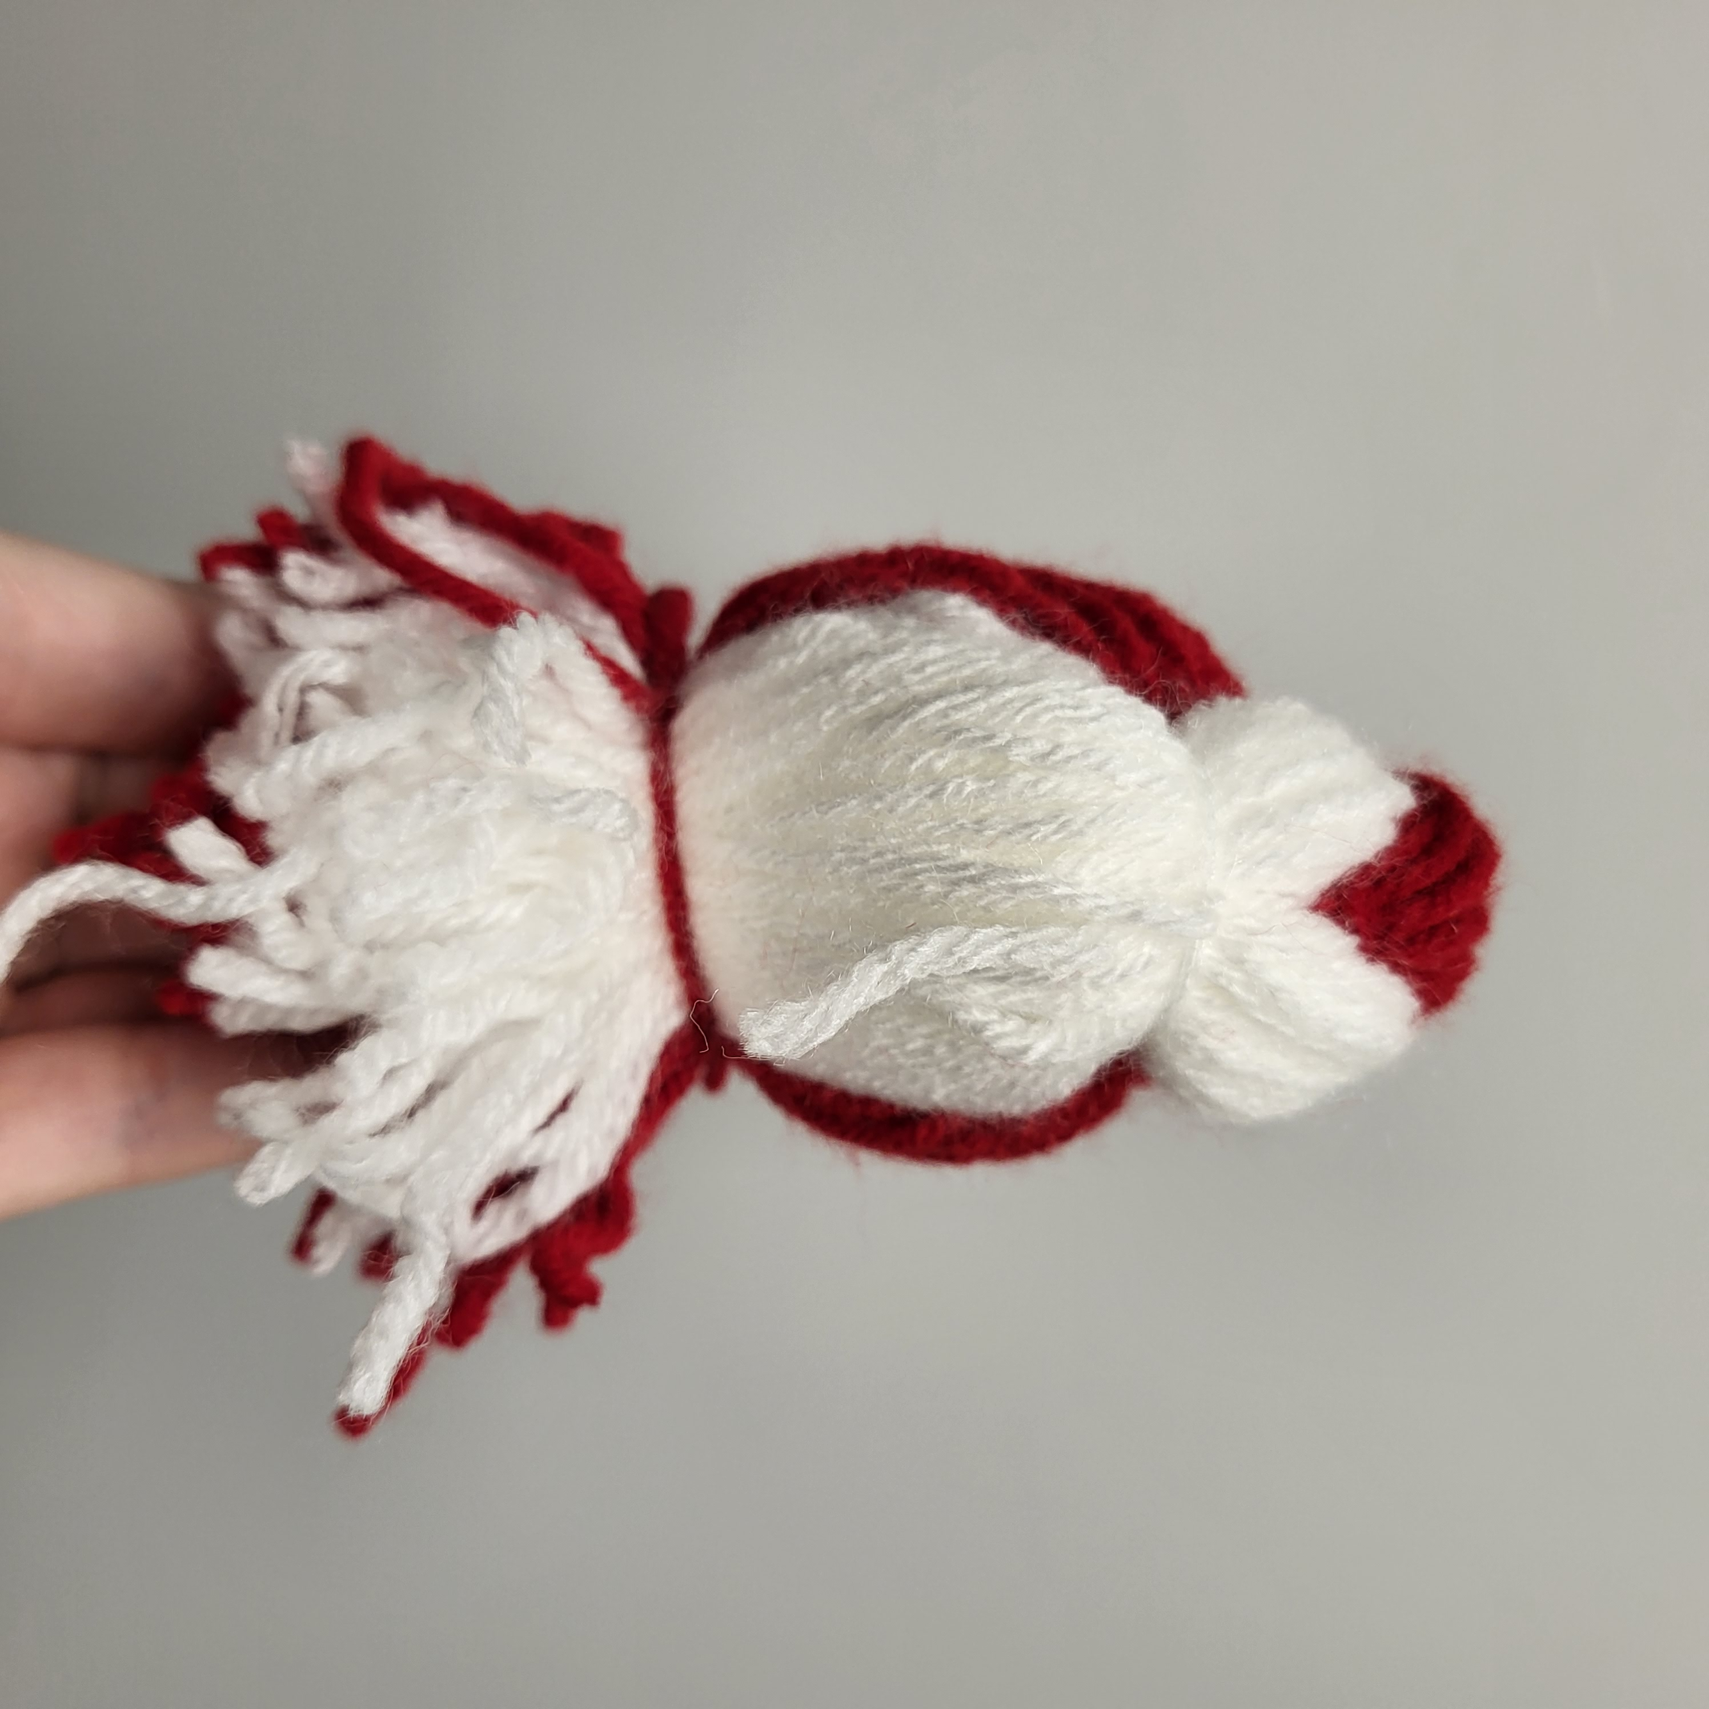
- Use the last yarn strand pulled out in Step 1 to wrap around the bottom several times before tying a knot.

- Trim any loose yarn on the front or end.

- Use tacky glue to carefully glue the beak to the center of the bird’s face.

- Peel and stick the vinyl eyes where you would like them.

- Stick two 3D printed legs into the base of the bird.

- Enjoy your very own yarn bird!

