Wine Bottle Caddy
Document Outline
- Overview
- Terminology and Shortcuts
- Creating Text
- Curving Text
- Aligning the Text
- Set Line Width
Overview
Using the template provided in Inkscape, create a personalized, laser etched wine bottle caddy cut from cherry wood.

Terminology and Shortcuts
Aspect Ratio Hold shift
Bounding Box Click, hold and drag your mouse
Copy CMD + C
Cut CMD + X
Group CMD + G
Ungroup CMD + Shift + G
Paste CMD + V
Positive Stop Shift + rotation tool
Select All CMD + A
Undo CMD + Z

Creating Text
- In the menu on the left side of the screen, click on the Text tool, which is the icon with the A.
- Click anywhere in the design area to create a text box and type words or dates that are important to you.
- To select all the letters in the text box, make sure you are still in the text box (there should be a blinking line where you were typing). Hold down CMD and hit the letter A on your keyboard.
- At the top of the page, you can change the size and type of the font. If you’re going to want to curve the text, change the alignment to “center.”
- If you want to put words or numbers above and below the caddy circle, I recommend creating two different text boxes.
- If this is all you want to do for your wine bottle caddy, skip down to the section called “Aligning the Text” on the last page.

Curving Text
Curving Above the Caddy Circle
If you want your words to curve, you will draw an oval that imitates the curve of the caddy.
- Hover over the shape tool on the left hand side menu.
- Select the ellipsis from the options that appear.
- Click, hold and drag to create an oval that looks similar to the curve of the caddy. If it isn’t perfect the first time, that’s ok.
  - Change your cursor back to an arrow on the menu at the top left of the screen, then adjust the sides of the oval. Move around as needed.
  - If you have a second set of words or numbers to go below the caddy, copy this oval and paste a second one off to the side for later.
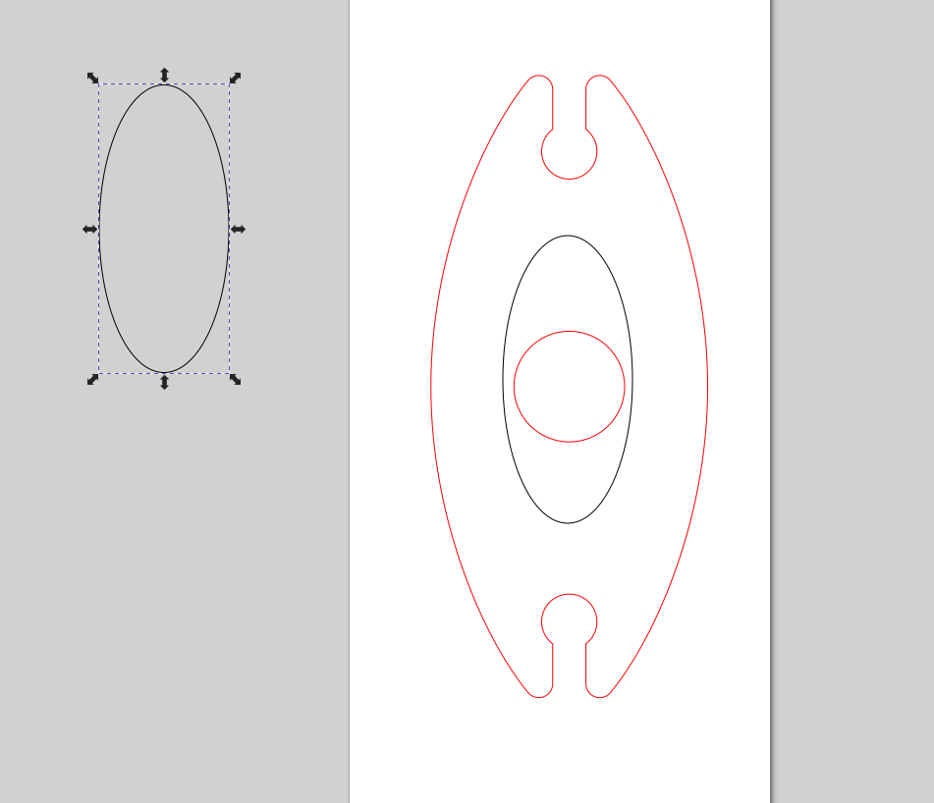
- Make sure your cursor is an arrow.
- We want to only select the oval and our line of text, so click off into the grey somewhere so nothing is selected. Next, hold down the SHIFT key as you click on the black line of the oval and the text line.
- Go to Text on the menu at the top of the page, then select Put on Path.
- If you centered the text earlier and then selected only the text and the one oval, your text should be joined to the oval, like this:
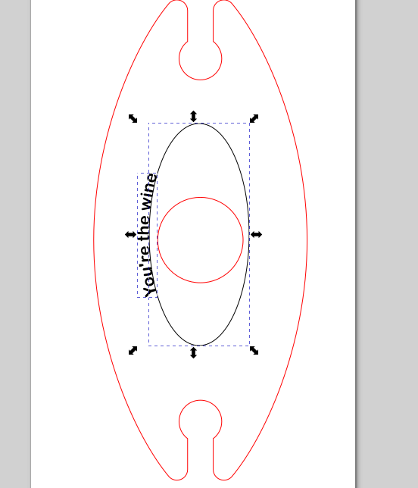
- At this point, double check that spelling and words are correct. After the next step, you will not be able to change any of the text.
- With the oval and the text still selected, go to Path on the menu at the top of the page, and select Stroke to Path.
- Click off into the grey so nothing is selected, then click on the black line of the oval only.
- Press the delete key on your keyboard. The oval should be gone and your words should be left behind in a curve.

Curving Below the Caddy Circle
With the oval in place in the middle, follow the same instructions to put the text on the path:
- Make sure both the straight (not curved) text and the oval is selected.
- Go to Text on the menu at the top of the page, then select Put on Path.
- If you centered the text earlier and then selected only the text and the one oval, your text should be joined to the oval, like this:
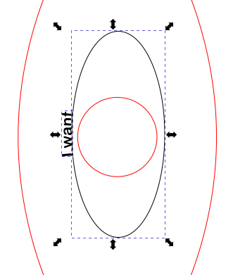
- With both the text and the oval still selected, flip them horizontally by going to the menu at the top and clicking this option:

- It should now look like this:
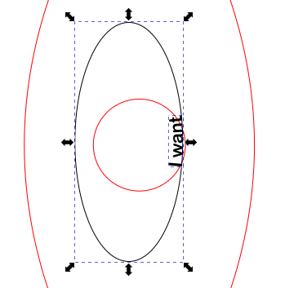
- Double check that spelling and words/dates are correct. After the next step, you will not be able to change any of the text.
- With the oval and the text still selected, go to Path on the menu at the top of the page, and select Stroke to Path.
- Click off into the grey so nothing is selected, then click on the black line of the oval only.
- Press the delete key on your keyboard. The oval should be gone and your words should be left behind in a curve.

Aligning the Text
- Move the text about where you want it.
- Make sure everything you don’t want is deleted.
- Hold down the CMD key and press the A on your keyboard to select everything in the design area.
- At the top of the screen, click on Object, and click on Align and Distribute at the bottom of the menu that appears.
- Another menu should appear on the right. Where all the icons of bars are, click on the one that will center on the horizontal axis. It looks like this:
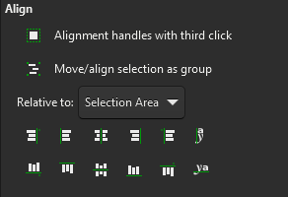
- Your words should now be mathematically centered relative to the template. However, sometimes mathematically aligned isn’t the same as visually aligned, so feel free to move the text around as you see fit.

Set Line Width
Lastly, we need to change the line thickness of the template so it will cut.
- Click on the red line of the template, go to the top of the page and click on Object. Select Fill and Stroke.
- From the menu that appears at the right side, click on Stroke Style.
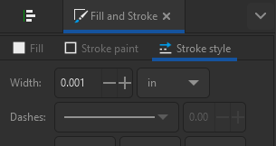
- Change the Width to 0.001 so that the laser cutter will cut this line, instead of etching.
- Your file is now ready for the laser cutter!

