Valentine’s Day Card Making
Document Outline
- Overview
- Terminology and Shortcuts
- Trace the Image
- Optional: Arrange with Release Compound Path
- Arranging and Cutting
Overview
We will be making a Valentine’s Day card with the Silhouette Studio program and cutting machine. We will import an image, trace it and then use some point editing to adjust our image. Finally, we will place it on our card template and to get it ready to cut.

The dimensions of the card when folded are 5.75” by 3.75”. The dimensions of the rectangle insert are 5.25” by 3.25”.

Terminology and Shortcuts
Aspect Ratio Hold shift
Bounding Box Click, hold and drag your mouse
Copy CMD + C
Cut CMD + X
Group CMD + G
Ungroup CMD + Shift + G
Paste CMD + V
Positive Stop Shift + rotation tool
Select All CMD + A
Undo CMD + Z

Trace the Image
- Click and drag the “Be” and “Mine” based on where you’d like them to be on your card.
- Click the trace button in the right tool bar. It is the sixth icon down and looks like a butterfly:
- Click Select Trace Area, then draw a bounding box around your shape. The entire image will appear yellow in the trace dialog to indicate that is what will be traced.
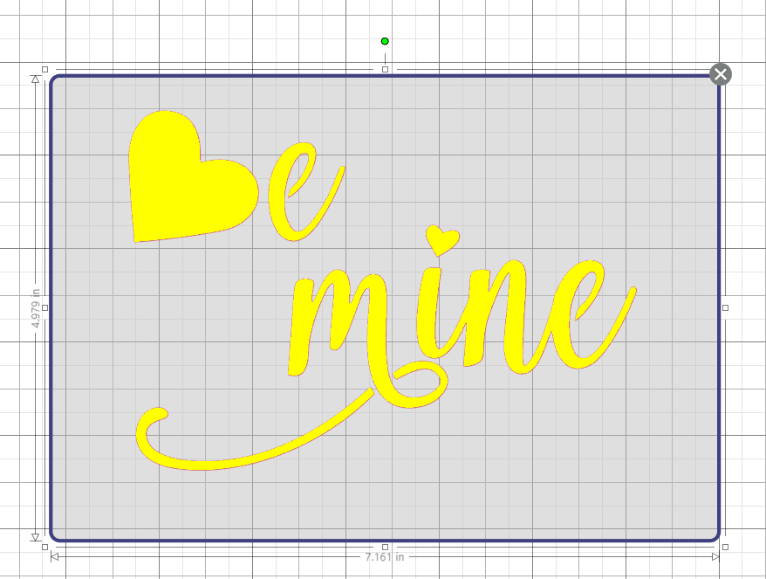
- In the menu on the right, click Trace.
- Click, hold and drag away “Be Mine” to leave behind the traced red lines.
- Keep the trace with the red lines, but click on the image you traced and press the delete key.
Optional: Arrange with Release Compound Path
If you would like to move around the different parts of the design again:
- Right-click on one of the red lines and select “Release Compound Path.” This will break the design into pieces. Be aware that the heart of the “i” and the bottom swoop of the “m” will no longer be connected to their respective letters.
- To keep them together, draw a bounding box around the pieces you want.
- Right-click on one of the red lines of those pieces and select “Group.”

Arranging and Cutting
- Arrange your words on the card template.
- Turn on the Silhouette cutting machine.
- At the top right of the screen, click Send.
- Settings for this project are:
