Wine Bottle Caddy
Document Outline
- Overview
- Terminology and Shortcuts
- Creating Text
- Aligning the Text
- Set Line Width
Overview
Using the template provided in Inkscape, create a personalized, laser etched wine bottle caddy cut from cherry wood.

Terminology and Shortcuts
Aspect Ratio Hold shift
Bounding Box Click, hold and drag your mouse
Copy CMD + C
Cut CMD + X
Group CMD + G
Ungroup CMD + Shift + G
Paste CMD + V
Positive Stop Shift + rotation tool
Select All CMD + A
Undo CMD + Z

Creating Text
- In the menu on the left side of the screen, click on the Text tool, which is the icon with the A.
- Click anywhere in the design area to create a text box and type words or dates that are important to you.
- To select all the letters in the text box, make sure you are still in the text box (there should be a blinking line where you were typing). Hold down CMD and hit the letter A on your keyboard.
- At the top of the page, you can change the size and type of the font.
- If you want to put words or numbers above and below the caddy circle, I recommend creating two different text boxes.

Aligning the Text
- Move the text about where you want it.
- Make sure everything you don’t want is deleted.
- Hold down the CMD key and press the A on your keyboard to select everything in the design area.
- At the top of the screen, click on Object, and click on Align and Distribute at the bottom of the menu that appears.
- Another menu should appear on the right. Where all the icons of bars are, click on the one that will center on the horizontal axis. It looks like this:
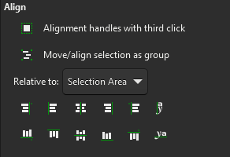
- Your words should now be mathematically centered relative to the template. However, sometimes mathematically aligned isn’t the same as visually aligned, so feel free to move the text around as you see fit.

Set Line Width
Lastly, we need to change the line thickness of the template so it will cut.
- Click on the red line of the template, go to the top of the page and click on Object. Select Fill and Stroke.
- From the menu that appears at the right side, click on Stroke Style.
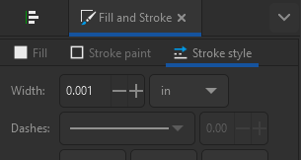
- Change the Width to 0.001 so that the laser cutter will cut this line, instead of etching.
- Your file is now ready for the laser cutter!

