Cutout Card with Silhouette
Document Outline
- Overview
- Make the Frame
- Weld the Pieces
- Put It All Together
- Sources
Overview
Create a card for the upcoming holiday, or for anyone special in your life. Using the Silhouette software, we will make a card and then cut it out. We will also add a vinyl phrase.

Make the Frame
- The card has already been created for you and you should see the template in the design area, with the dimensions of:
  - Card layout: 9”x4.5”
  - Inner window: 2.5”x2.5”
  - Center fold perforation: 4.3”
- Import the image of a trophy silhouette into the Silhouette program
- On the right side menu, click on the Trace panel (looks like a butterfly), then click “Select Trace Area”
- Click, hold and drag to create the trace area around the trophy, like this:
- Move the box around as needed until the trophy is inside the box
- From the Trace panel, select “Trace”
- Click on the white space of the image and hit the delete button on your keyboard, leaving you with the red outline of the trophy

Weld the Pieces
- Move the red outline of the trophy to the inner right square window of the card
- Resize the trophy so that it fits inside the window, touching all four walls (you may need to unlock the aspect ratio by clicking the padlock next to the dimensions)
- You want the four sides of the trophy to be connected to the card, so make sure the edges overlap a little on the square
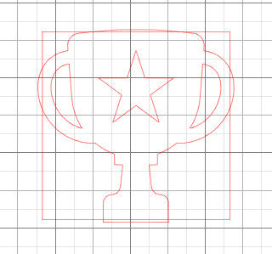
- Click, hold and drag across the inner box and the trophy to select them both
- On the right-side menu, click the Modify panel (looks like a rectangle broken into pieces)
- In the Modify panel, click “Subtract” and this is what your trophy should now look like:
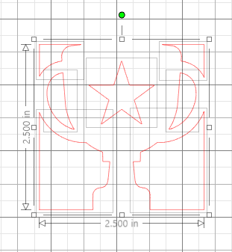
You should see the edges of the trophy were cut off where they touched the inner square window, but also there are light gray lines. These are all separate pieces.

- Click off into the gray area to deselect all of the extra pieces
- Click on the star and hit the delete key on your keyboard because we will not need that
- Click, hold and drag across the pieces of the trophy that are left to select them all
- Right click on one of the red lines and select “Group” to keep them together

Cut Out Card
- Plug your laptop into the Silhouette machine
- At the top right of the Silhouette Studio software, click “Send”
- Start with these cut settings (you may need to adjust in the future based on paper thickness and blade sharpness):
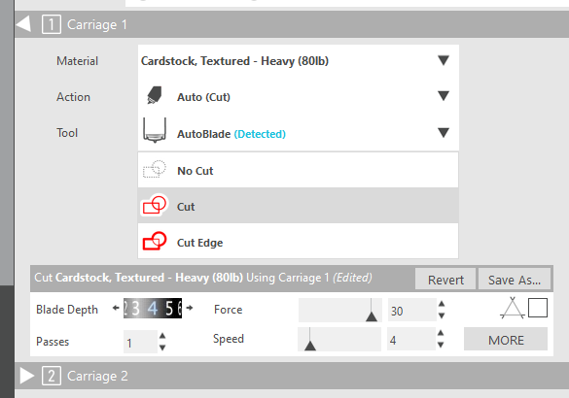
- Lay the paper on the sticky mat and load the mat into the machine
- Click “Send” at the bottom right of your screen

Put It All Together
- Carefully peel off your card from the stick mat once it is cut out
- Put a dab of glue on each of the four corners of 3”x3” piece of craft paper, and stick it behind the window with the trophy
- Use transfer paper to transfer vinyl phrase onto the trophy
- Write a meaningful message inside and give it to someone to tell them how much they mean to you

Sources
https://www.silhouette101.com/archives/make-customized-window-cards

