Windows Laptops

Document Outline
- Overview
- Getting Started
- Navigating
- Open For Questions
Overview
For today’s class, I will give you a simple “Getting Started” Introduction to Windows Laptops. In everyday life, each computer may have slight variations based on the brand or Windows software (Windows 7 vs. Windows 10 vs. Windows 11) loaded on the computer. However, there are key features that I will show you today that should make your experience with Windows a little bit easier. After I introduce these topics, I will then open up our time for your questions, which we will all go through together.

Getting Started
This might sound like a lot to you as a beginner user of a laptop, but it is good to know when something goes a little funny on your computer as you use it, it might be something as simple as accidentally pressing on the wheel too hard. Knowing what happened can help you to either avoid it in the future or resolve it quickly, like just clicking the wheel on the mouse one more time.

Using the Mouse
- Left click
- Right click will be specifically stated
- Right clicking can give you menu options. These aren’t all the menu options, but programmers have tried to put all the most frequently used options into that tiny menu
  - Cut, copy, and paste in a Word document or email
  - Reload, forward and back in an Internet browser
- Unless otherwise stated, if someone says to click, they mean left click

Wheel of the Mouse
- In the middle, there is a wheel that you can roll with your finger
- This causes “scrolling” which means that it can move the page up or down, if that is available
- If pressure is added to that wheel, it will “click,” causing the scroll to be controlled by movement of the mouse instead of rolling the wheel – this causes a lot of confusion. Just press the wheel again to stop it

Touchpad
- Moving one finger across the touchpad moves the mouse
- Moving two fingers across the touchpad causes scrolling
- Tapping one finger can be like a left click of a mouse
- Tapping two fingers can be like the right click of a mouse
- The space at the bottom of the pad can be used for a left click or a right click when pressure is applied to the left side or the right side
- Not necessary if you have a mouse plugged in, but good to be aware of it as you type
- If your palm hits the pad, it could click somewhere else – also causes confusion

Navigating
Much of how computers operate is based on desk organization, so many terms might sound familiar. You can use these terms to orient yourself around how you can best use these features.
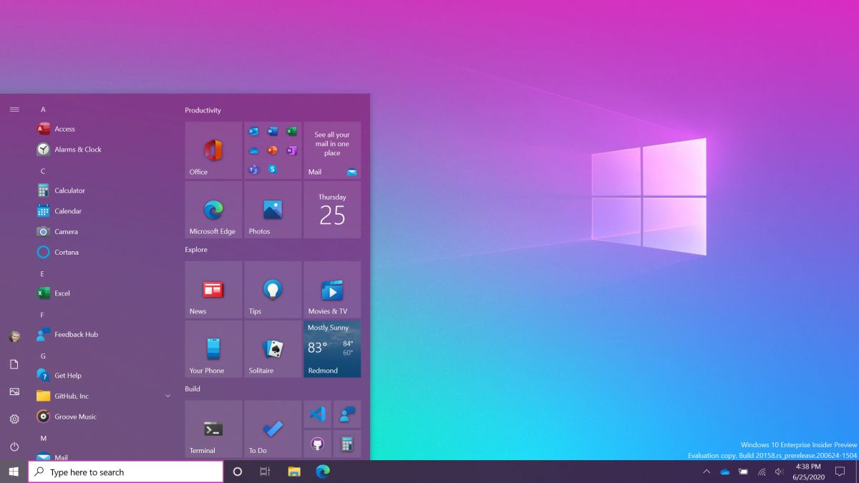
Start Menu
Desktop
Task Bar
Desktop – The main background of your computer and a place where files or shortcuts can be kept for quick access

Task Bar – What programs or applications are currently open
- Pin your most frequently used applications to bottom of screen for quick access
- Hovering over an icon on the taskbar and then right clicking will give you the option to pin (or unpin)

Start Menu – Where you configure the settings of your computer
- Shutdown, restart, sign out options
- Manage and customize layout of applications
- Search for applications – when in doubt, search!
- Access settings to customize various features of the computer
  - Display, printer, WiFi, run updates, uninstall apps, individual user accounts
  - Recommend playing with display and mouse options for best user experience

File Explorer – Where all of your files live
- Storage locations such as desktop, documents, downloads, and pictures are separated into folders
- Several different view options for document icons and information
- You can move files between folders by clicking and dragging
- Create a new folder by right clicking and choosing new>folder

Application Windows
- On the title bar (top bar), it shows what folder you are currently in. In this case: Documents
- On the right side of the bar, there are 3 options:
  - Minimize
  - Maximize
  - Close
- Clicking and holding on the title bar (top bar) will allow you to move around the window
  - Helpful to see what is behind the window
  - Can be used to put two windows next to each other in order to move files from one window to another
  - Example: Moving a file from Downloads to Documents, or organize your Pictures

Pointer
- As you get used to using a laptop, pay attention to how the mouse presents itself on your screen (arrow or a hand for clicking)
Open For Questions!

